|  |
| --- |
| Close-up image showing the leaf-sides of two oversized books side-by-side on a bookshelf, with additional books in soft focus background |
| Azure Active Directory  Integration Guide with Web Access Management using F5 BIG-IP Access Policy Manager (APM) |
| |  |  |  | | --- | --- | --- | |  |  |  | |

Contents

Introduction 2

Prerequisites 3

Access guided configuration 3

Guided Configuration 5

Header Based Application 5

Setting up Azure Active Directory Integration 5

Configuring F5 BIG-IP 8

Testing the Integration 15

Kerberos Application 17

Setting up Azure Active Directory Integration 17

Configuring F5 BIG-IP 19

Testing the Integration 26

Advanced Configuration 29

Kerberos SSO Configuration 29

Configuring an Active Directory AAA server 29

SAML Configuration 31

**Setting up Kerberos Delegation** 45

Appendix 47

SAML – F5 BIG-IP Variable mappings 47

Adding Custom Claims 49

# Introduction

This guide covers Integration of Azure Active Directory and F5 BIG-IP APM (Access Policy Manager). The document describes ability to secure publish the application using F5 and be able to securely Integrate with Azure AD Platform leveraging some of the core functionalities like Azure AD Conditional Access and Identity Protection Services.

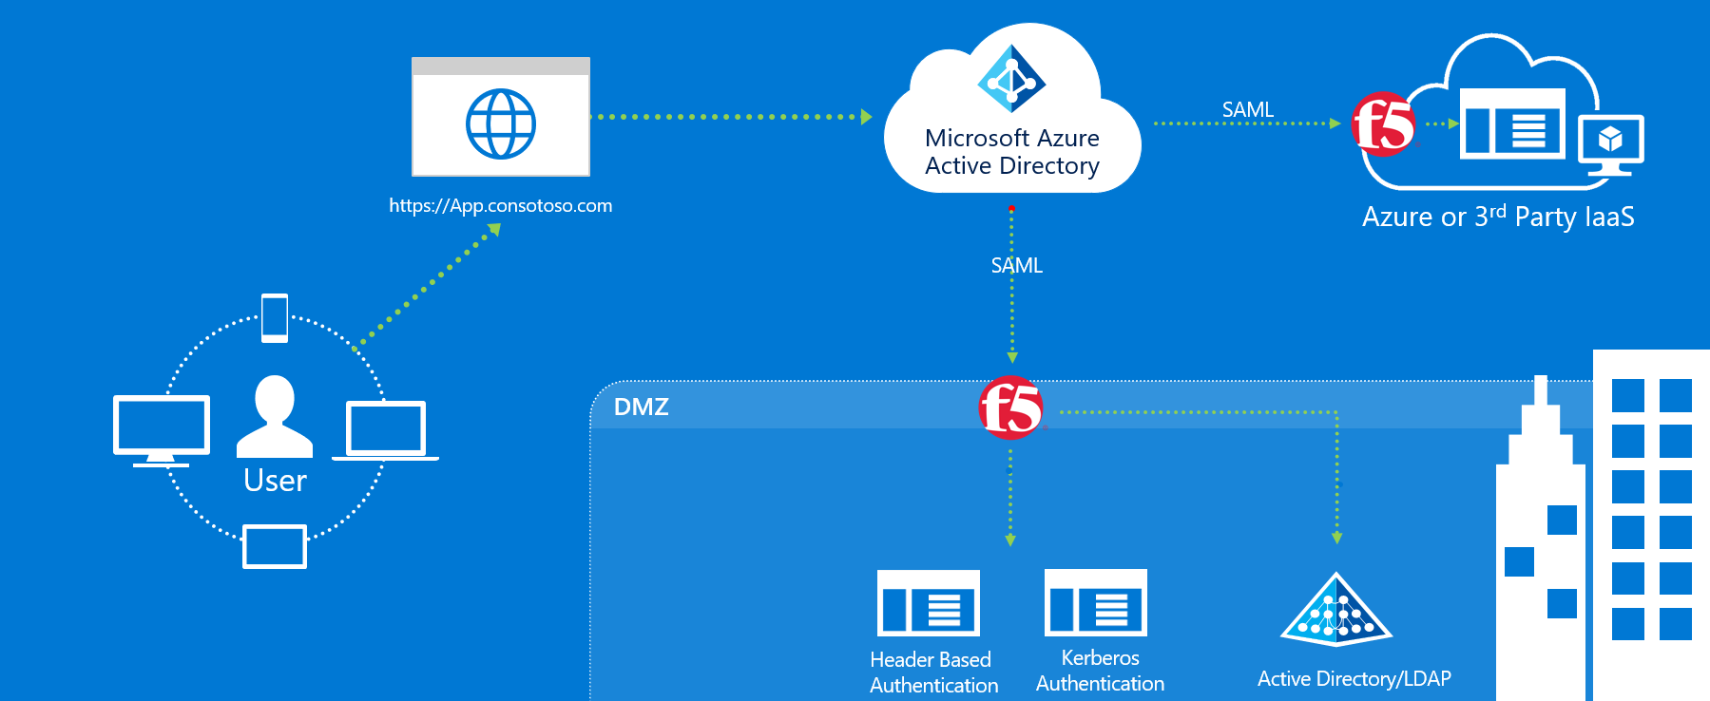

The Above Integration allows enterprises to leverage F5 with Azure AD to cover the both Modern authentication and Kerberos and header Authentication using Azure Active Directory as control Plane.

|  |  |  |  |
| --- | --- | --- | --- |
| **SNo** | **Scenarios** | **Azure AD** | **F5 BIG-IP** |
| 1 | Header Based Authentication | SAML IDP - Azure Conditional Access / Identity Protection Services | SAML SP - Maps SAML Assertion to HTTP Headers for Application consumption |
| 2 | Kerberos Authentication | SAML IDP - Azure Conditional Access / Identity Protection Services | SAML SP - Performs KCD for Single Sign on for Kerberos Applications |

# Pre-requisites

1. Deploying the joint solution requires the following license:

* F5 BIG-IP® Best bundle (or)
* F5 BIG-IP Access Policy Manager™ (APM) standalone license
* F5 BIG-IP Access Policy Manager™ (APM) add-on license on an existing BIG-IP F5 BIG-IP® Local Traffic Manager™ (LTM).
* In addition to the above license, the F5 system may also be licensed with:
  + A URL Filtering subscription to use the URL category database
  + An F5 IP Intelligence subscription to detect and block known attackers and malicious traffic
  + A network hardware security module (HSM) to safeguard and manage digital keys for strong authentication

1. F5 BIG-IP system is provisioned with APM modules (LTM is optional)
2. Although optional, it is highly recommended to Deploy the F5 systems in a [sync/failover device group](https://techdocs.f5.com/kb/en-us/products/big-ip_ltm/manuals/product/big-ip-device-service-clustering-administration-14-1-0.html) (S/F DG), which includes the active standby pair, with a floating IP address for high availability (HA). Further interface redundancy can be achieved using the Link Aggregation Control Protocol (LACP). LACP manages the connected physical interfaces as a single virtual interface (aggregate group) and detects any interface failures within the group.
3. For Kerberos applications, an on-premises AD service account for constrained delegation. Refer to [F5 Documentation](https://support.f5.com/csp/article/K43063049) for creating a AD delegation account.

# Access guided configuration

‘Access guided configuration’ is supported on F5 TMOS version 13.1.0.8 and above. If your BIG-IP system is running a version below 13.1.0.8, please refer to the **Advanced configuration** section

Access guided configuration presents a completely new and streamlined user experience. This workflow-based architecture provides intuitive, re-entrant configuration steps tailored to the selected topology.

Before proceeding to the configuration, upgrade the guided configuration by downloading the latest use case pack from [downloads.f5.com](https://downloads.f5.com). To upgrade, follow the below procedure

Note – The screenshots below are for the latest released version (BIG-IP 15.0 with AGC version 5.0). The configuration steps below are valid for this use case across from 13.1.0.8 to the latest BIG-IP version.

* On the F5 BIG-IP Web UI, click on ***Access >> Guide Configuration***.
* On the **Guided Configuration** page, click on **Upgrade Guide Configuration** click on the top left-hand corner.

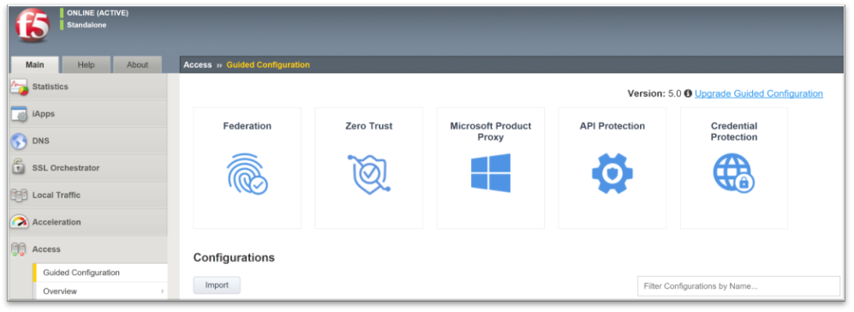

* On the Upgrade Guide Configuration pop screen, select the downloaded use case pack and click on **Upgrade and Install** button.

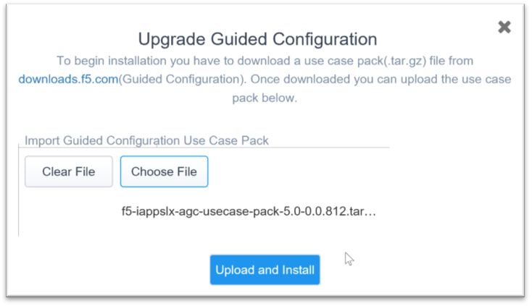

* When upgrade is completed, click on the **continue** button.

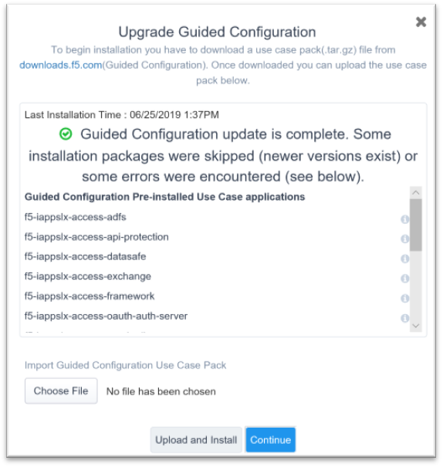

# Guided Configuration

## Header Based Application

### Setting up Azure Active Directory Integration

Select Enterprise Application Blade and Choose Non-gallery Application

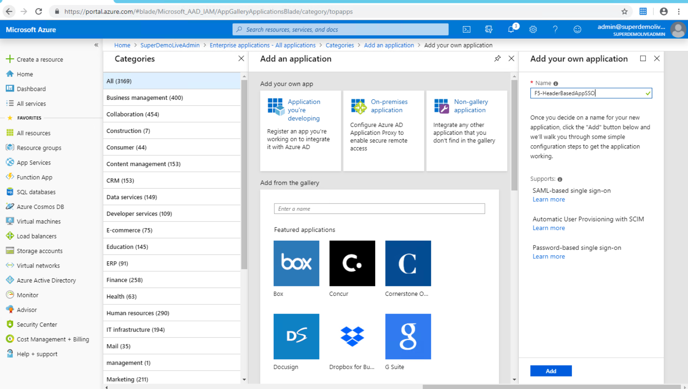

Specify SAML as the Single Sign-on method

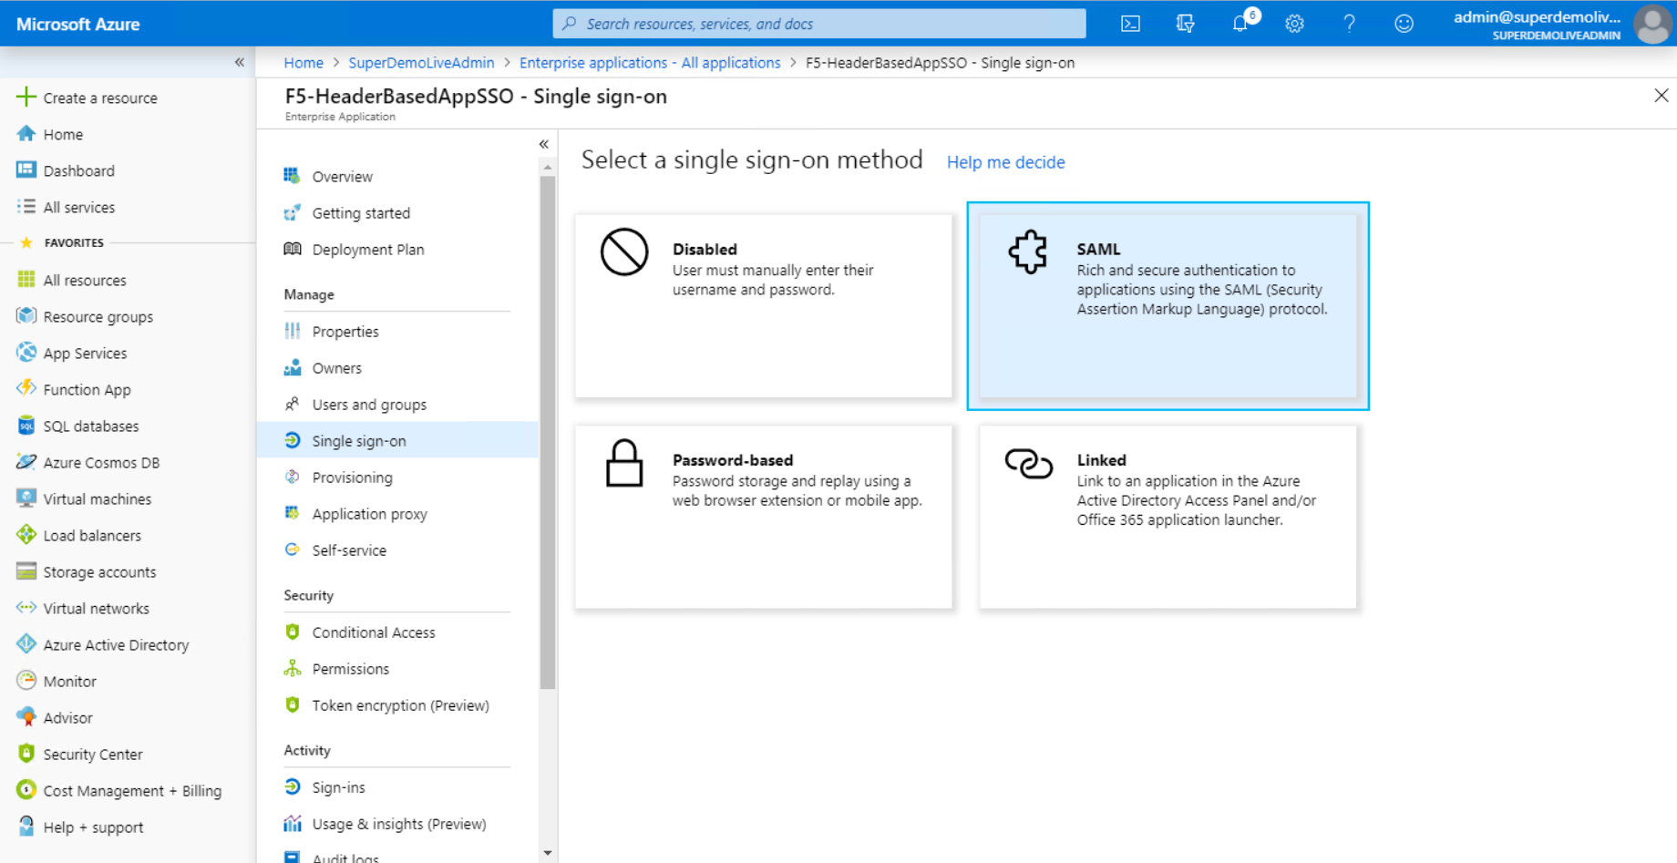

Complete the Basic SAML Configuration Section

Specify the Identifier (Entity ID) and Reply URL, in our example <https://headerapp.superdemol.live>

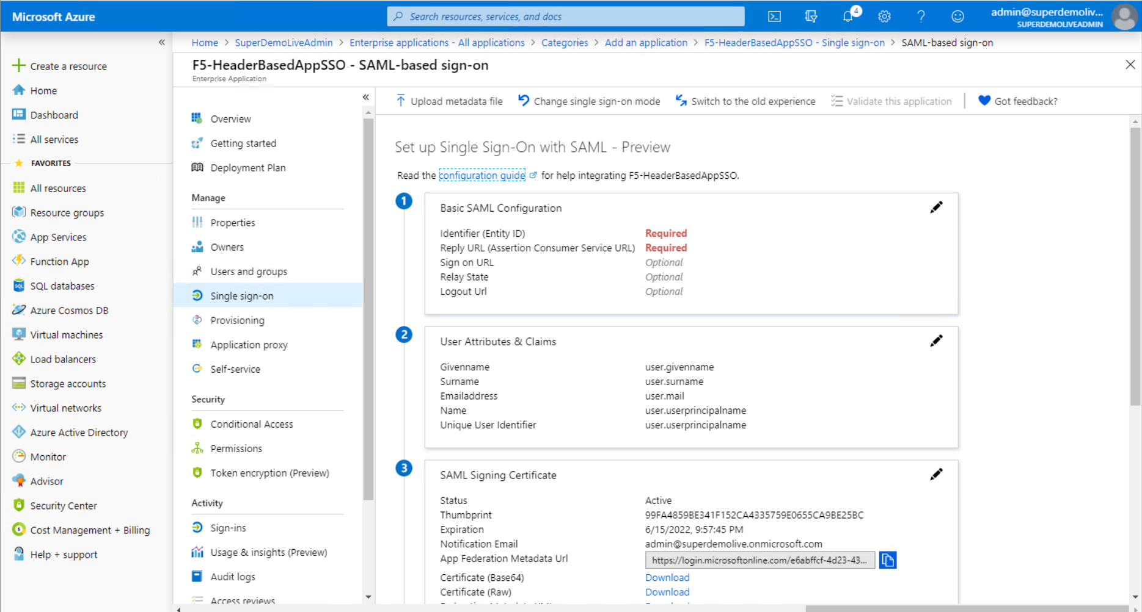

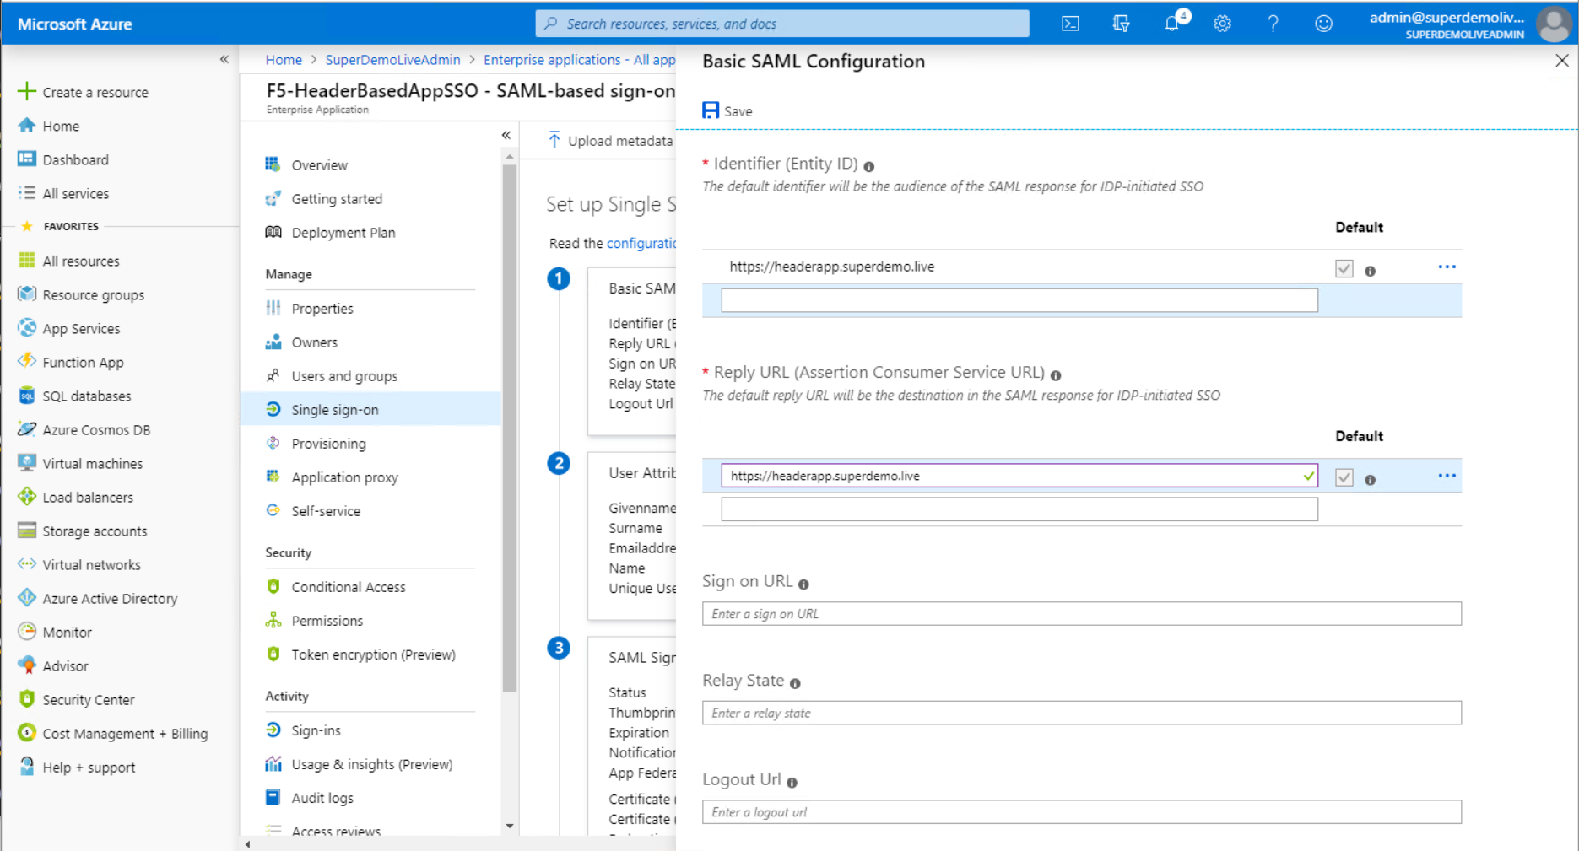

Download the Federation Metadata XML and the Certificate (Base64)

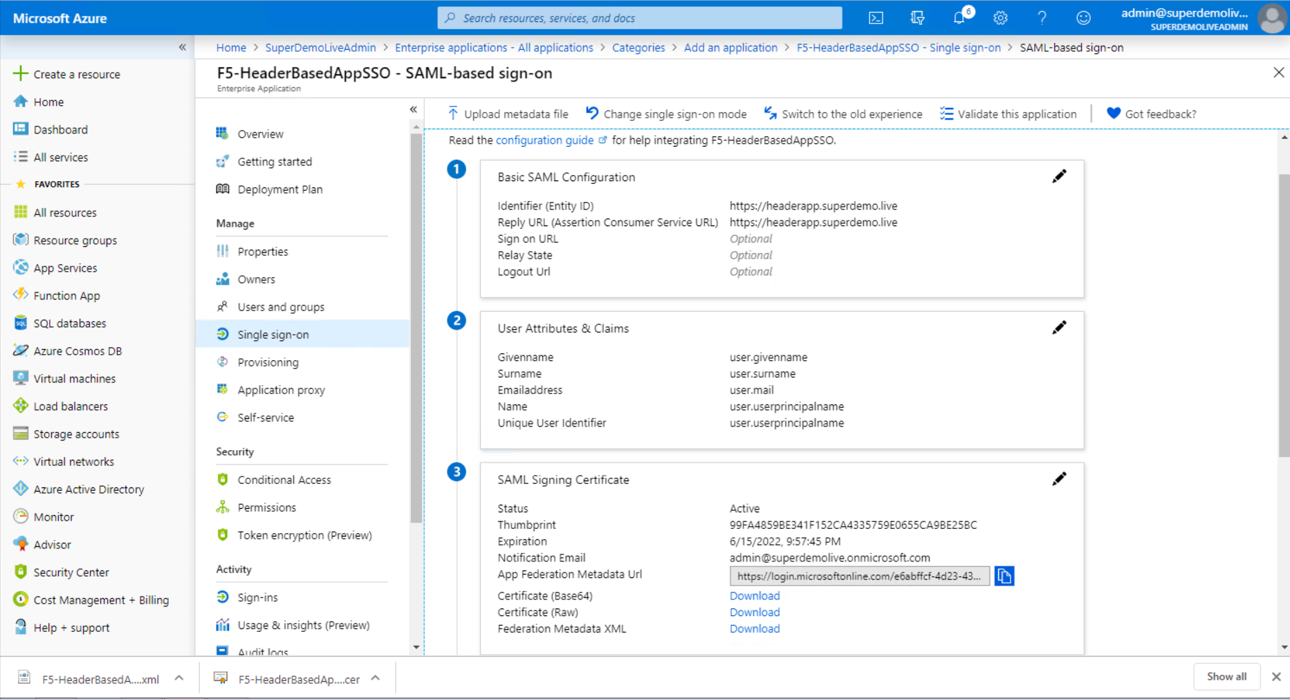

Navigate to the Users and Groups and Specify the users entitled for the Applications.

Doing this step at this point ensures you can test SSO once its configured on the F5 BIG-IP

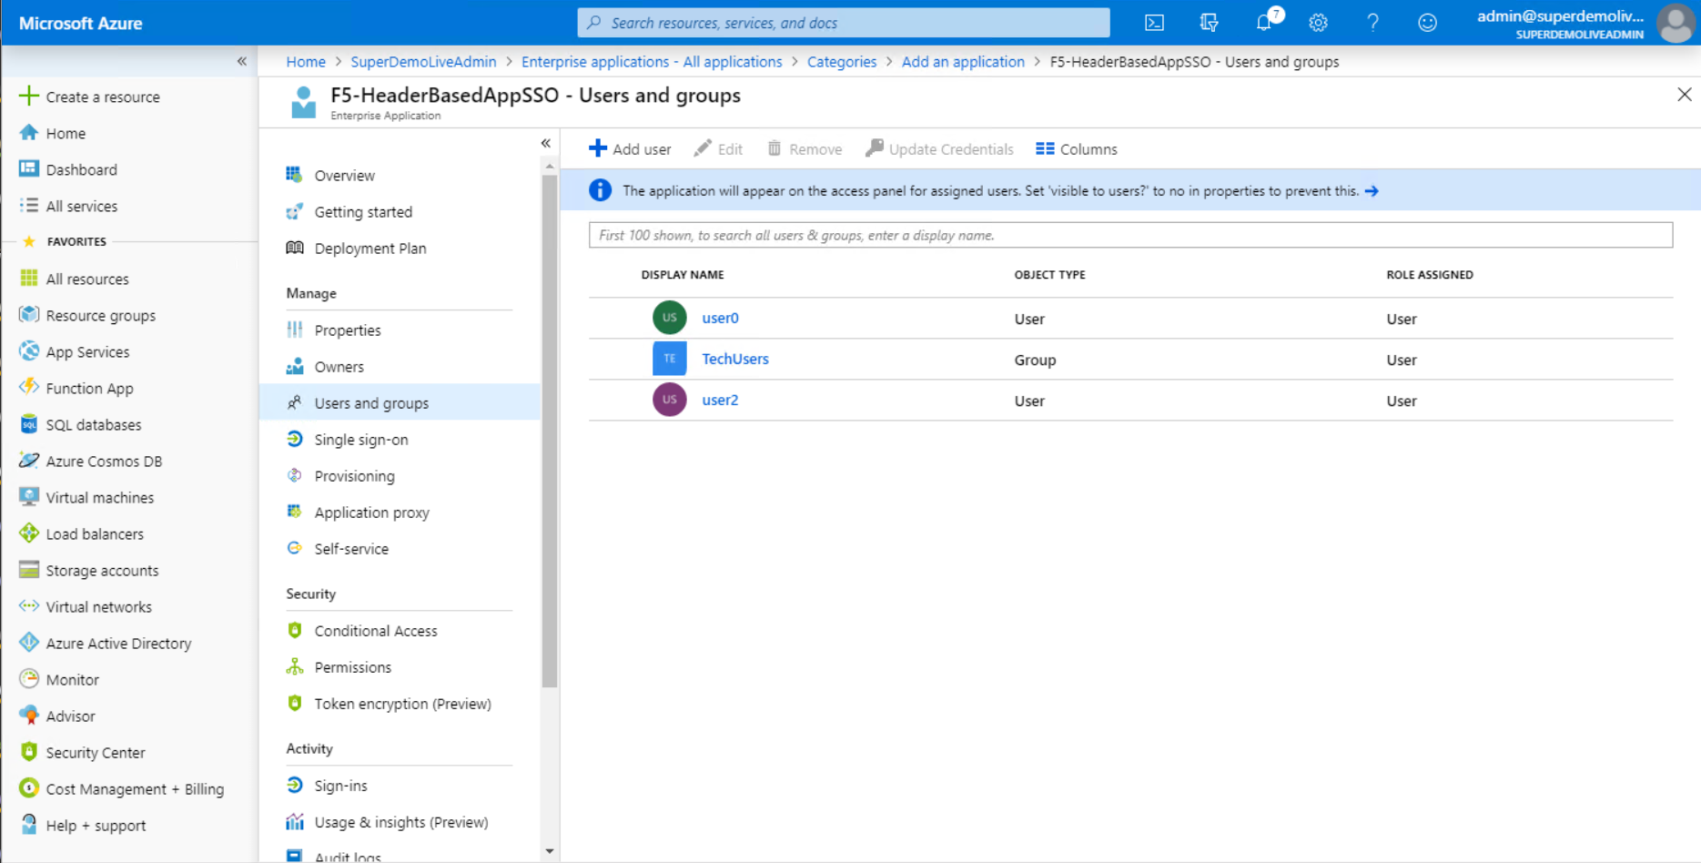

### Configuring F5 BIG-IP

You will need to import the Metadata Certificate into the F5 which will be used later in the setup process. From the BIG-IP management console navigate to System > Certificate Management > Traffic Certificate Management > SSL Certificate List. Select **Import** from the right-hand corner.

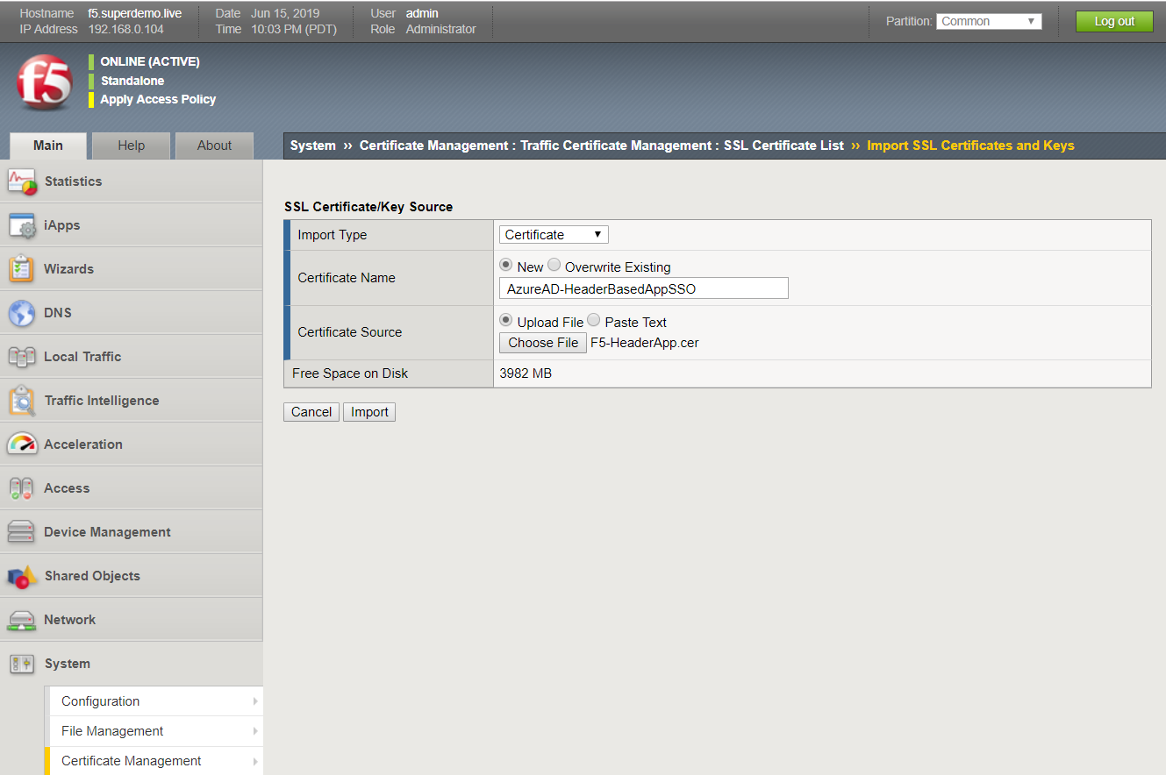

Additionally, you will need an SSL Certificate for the Hostname (**headerapp.superdemo.live**), in our example I am using a Wildcard Certificate.

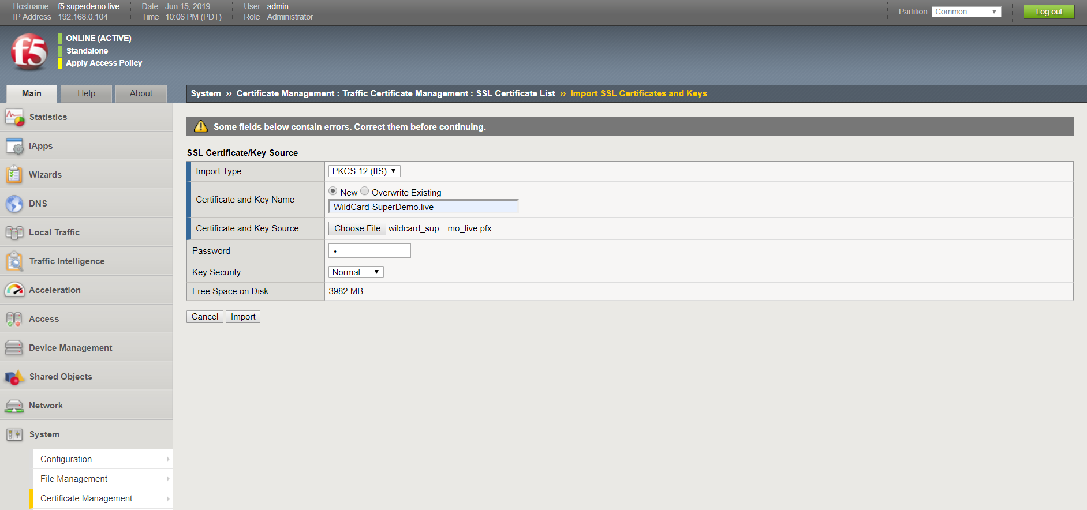

We will use the Guided Experience to setup the Azure AD Federation and Application Access.

Go to – F5 BIG-IP and select Access > Guided Configuration > Federation > SAML Service Provider and then click **Next**.

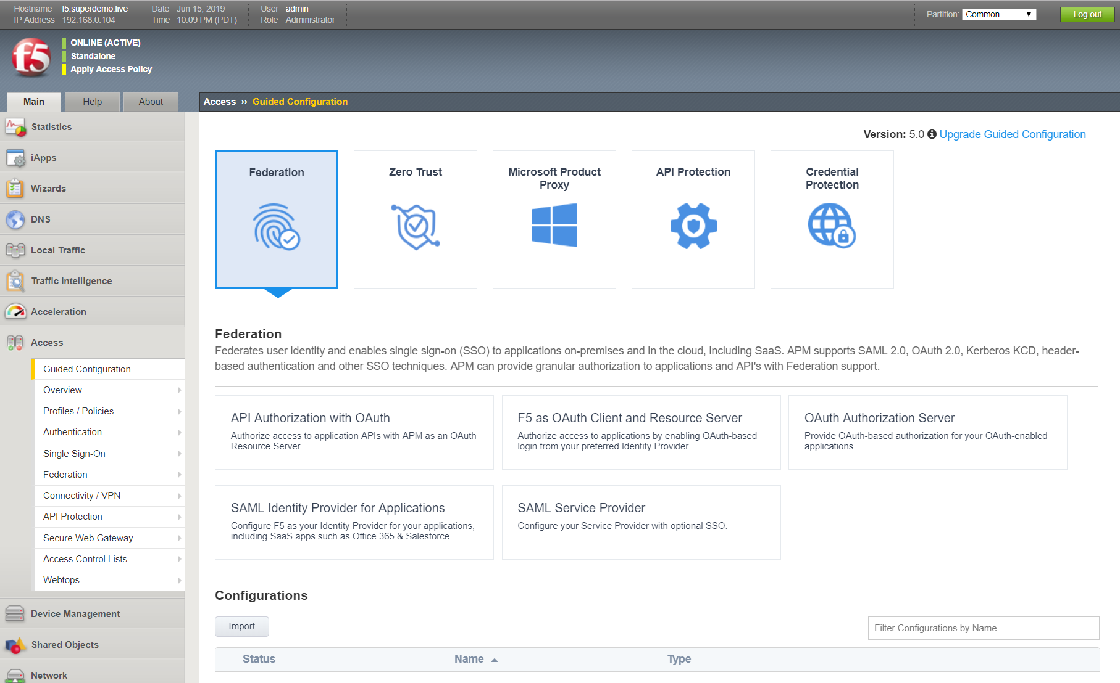

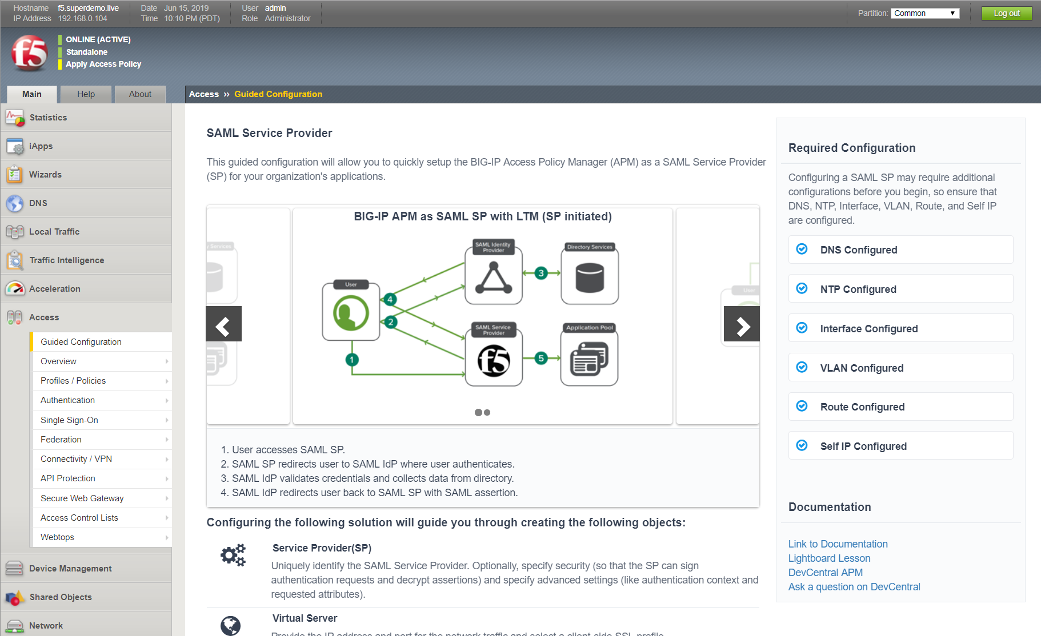

Select ‘Next to begin configuration. Provide a name for the configuration and specify the EntityID (same as what you configured on the Azure AD Application Configuration) and the entity host name. Accept the remaining default entries and then click **Save & Next.**

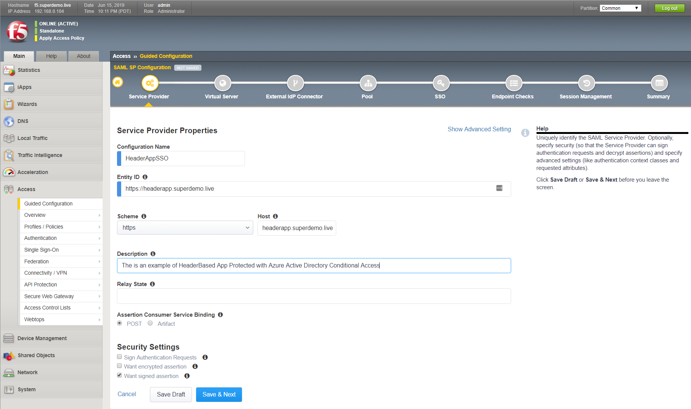

Create a new Virtual Server. Specify the external IP address to be associated with the Entity ID.

The Redirect Port configuration is optional. For the Client SSL Profile, select ‘Create new’ and choose the previously uploaded application certificate, (the wild card certificate in this example) and the associated key. Select ‘Associated Key, and then click **Save & Next**.

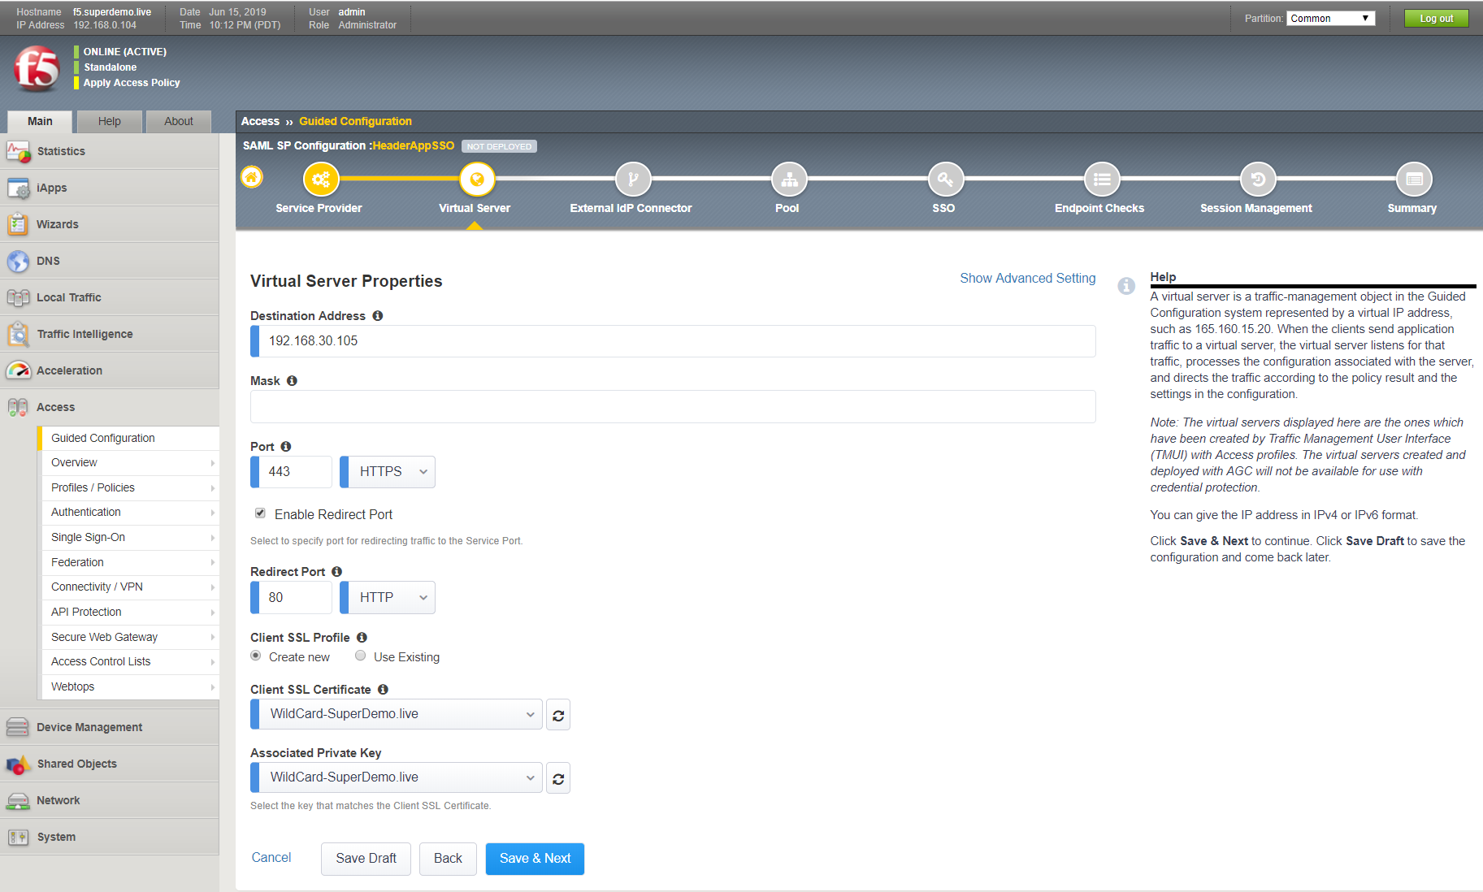

On the External Identity Provider screen, select ‘Metadata’ for the configuration method. Choose upload the configuration metadata and specify a new name for SAML IDP connector

You will also need to specify the Federation Certificate that was uploaded earlier. Select ‘, and then click **Save & Next**.

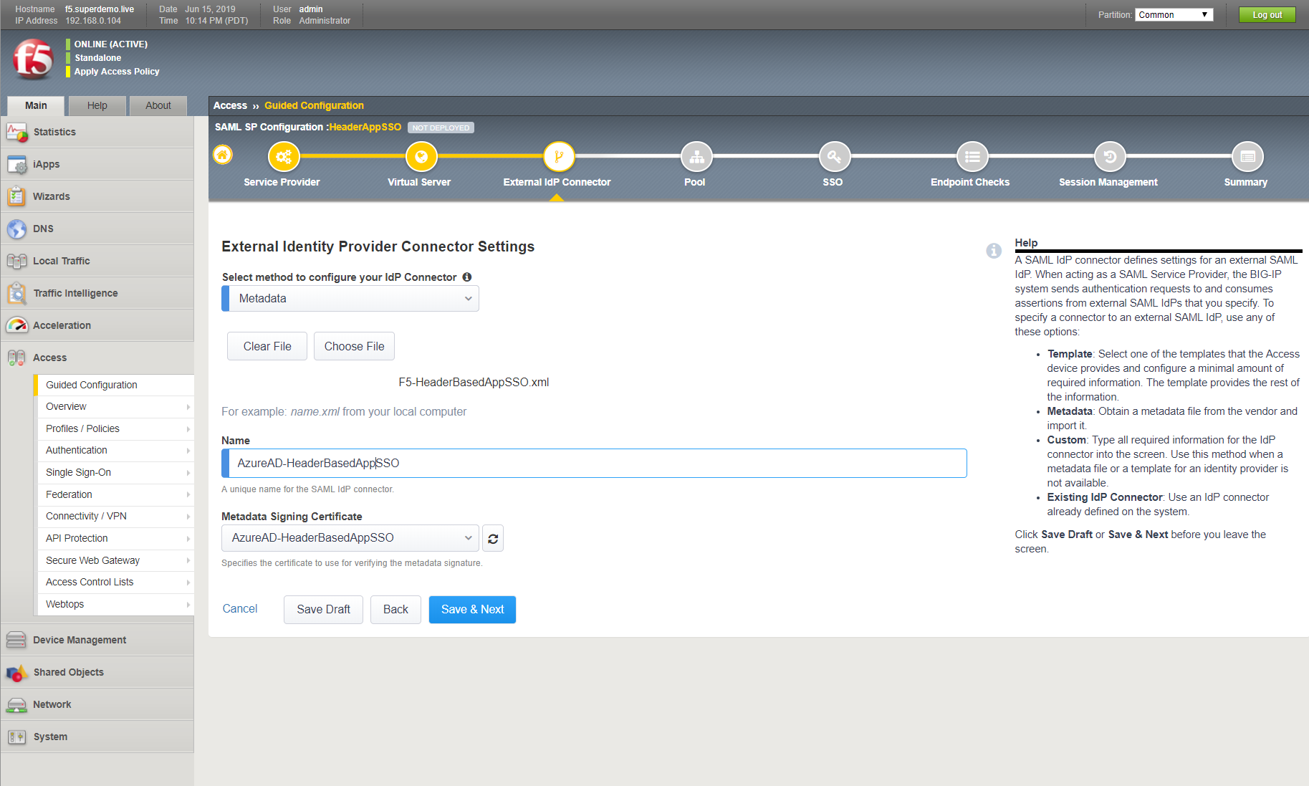

Create a new backend application pool. Specify the IP Address(s) of the backend application server(s).Backend Application Servers, and then click **Save & Next.**

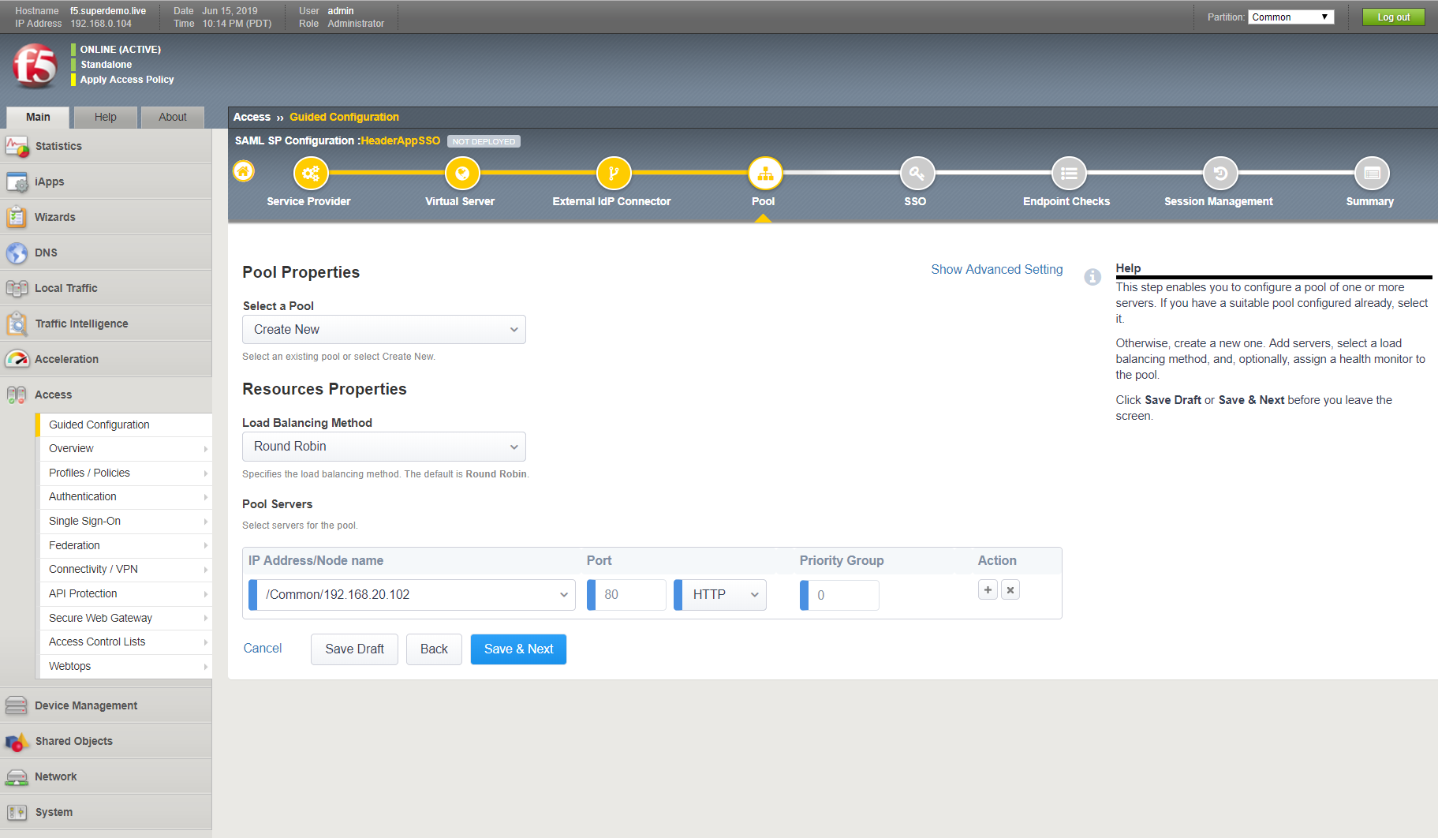

On the Single Sign-On Settings screen, select ‘Enable Single Sign-On’ and ‘HTTP header-based’ for the Sign-on Type, and then click **Save & Next**. In addition to the authorization header, you can add other headers based on your application needs. See the Appendix for the list of **SAML Session Variables.**

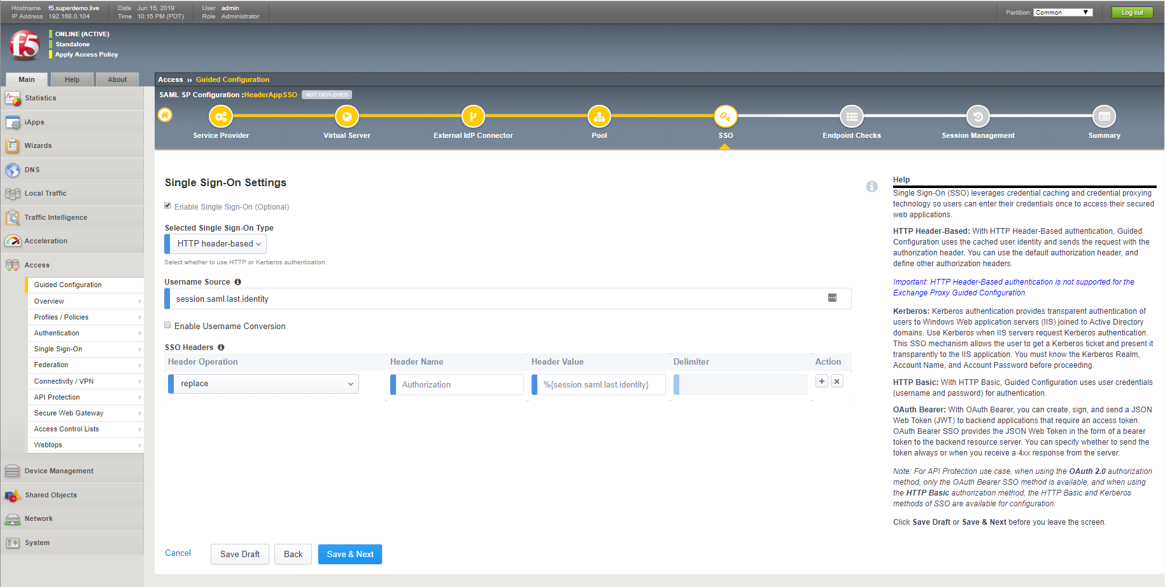

For purposes of this guidance, we will skip endpoint checks. Refer to F5 documentation for details. On Endpoint Check Properties screen, click **Save & Next.**

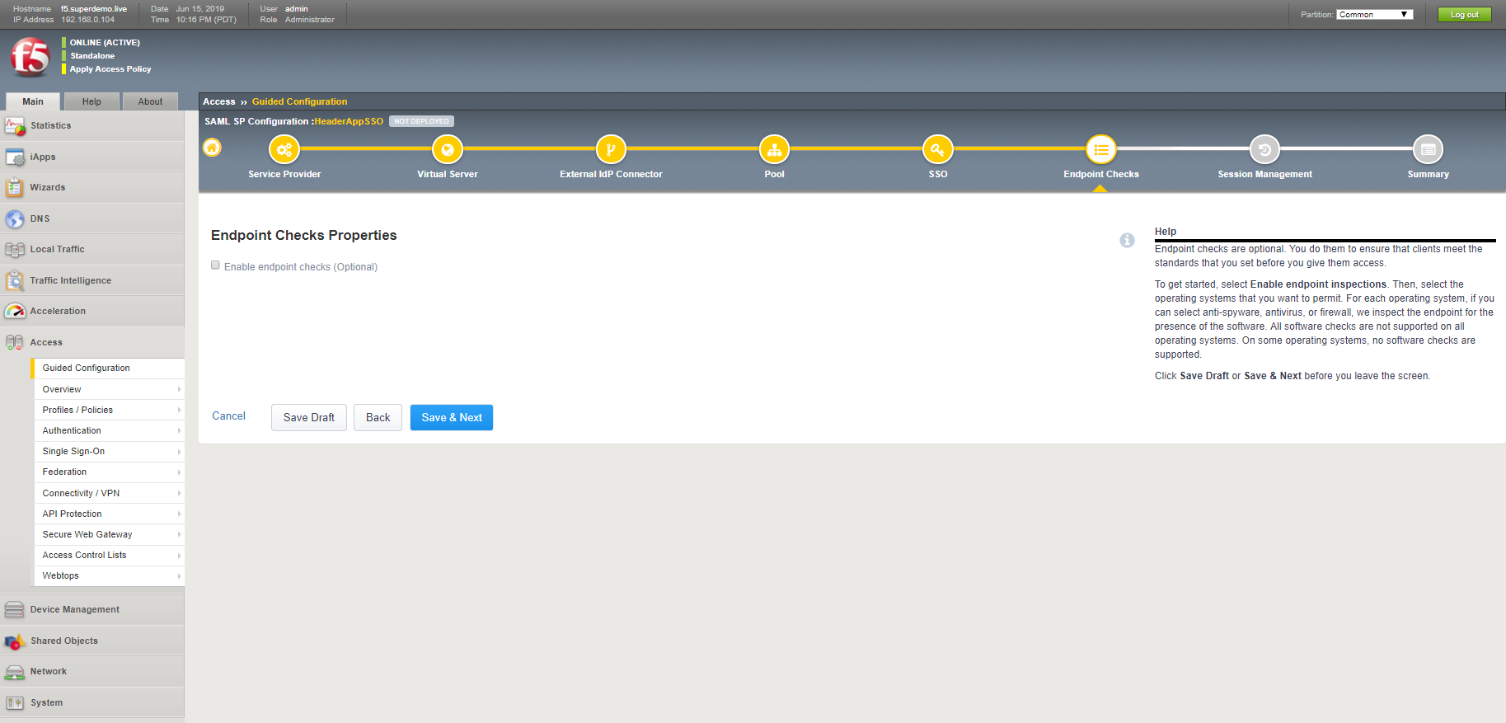

On the Timeout Settings screen, accept the defaults and click **Save & Next.** Consult F5 documentation for details regarding SAML session management settings.

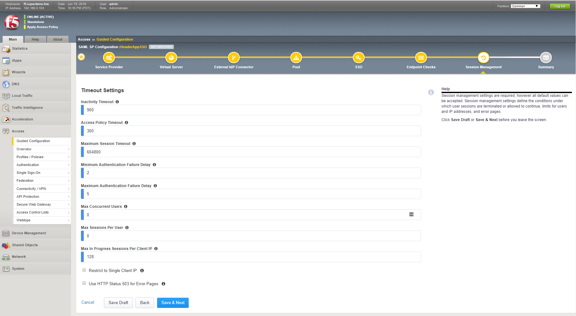

Review the summary screen and click **Deploy**. Once it’s deployed, click on **Finish**.

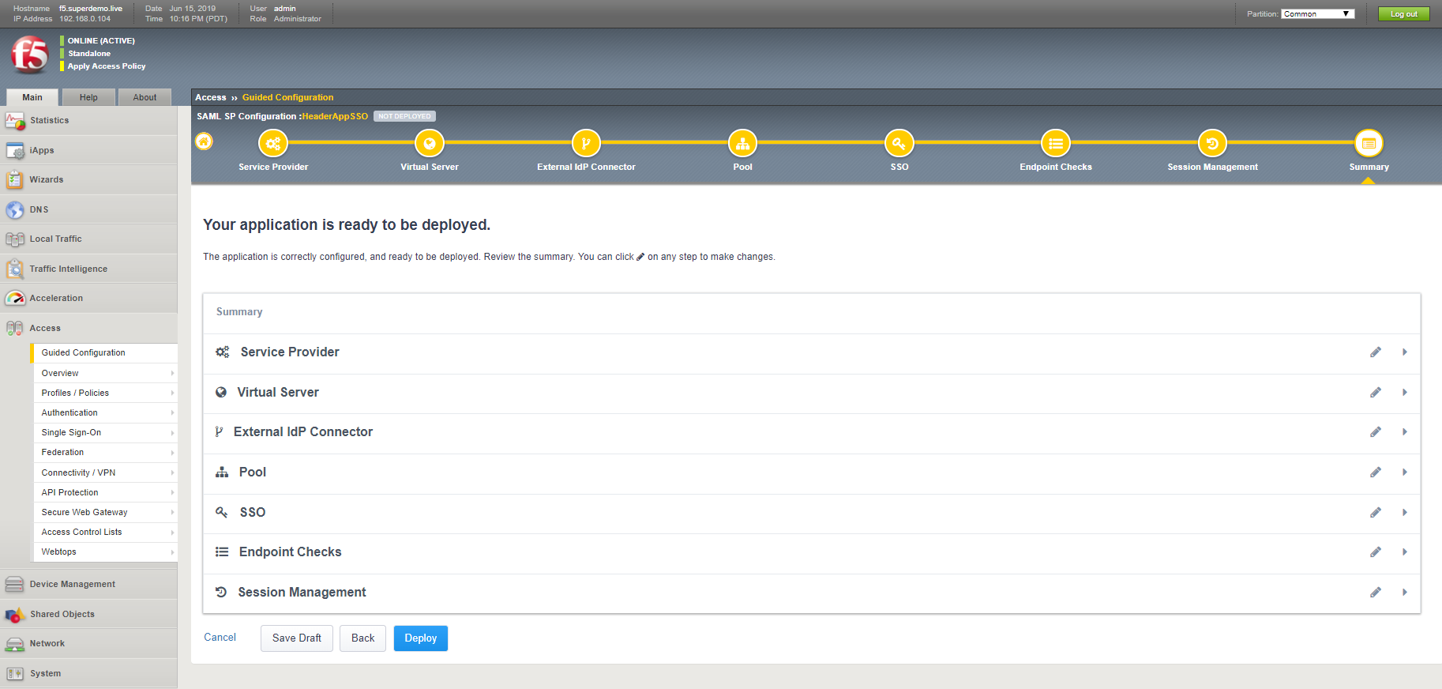

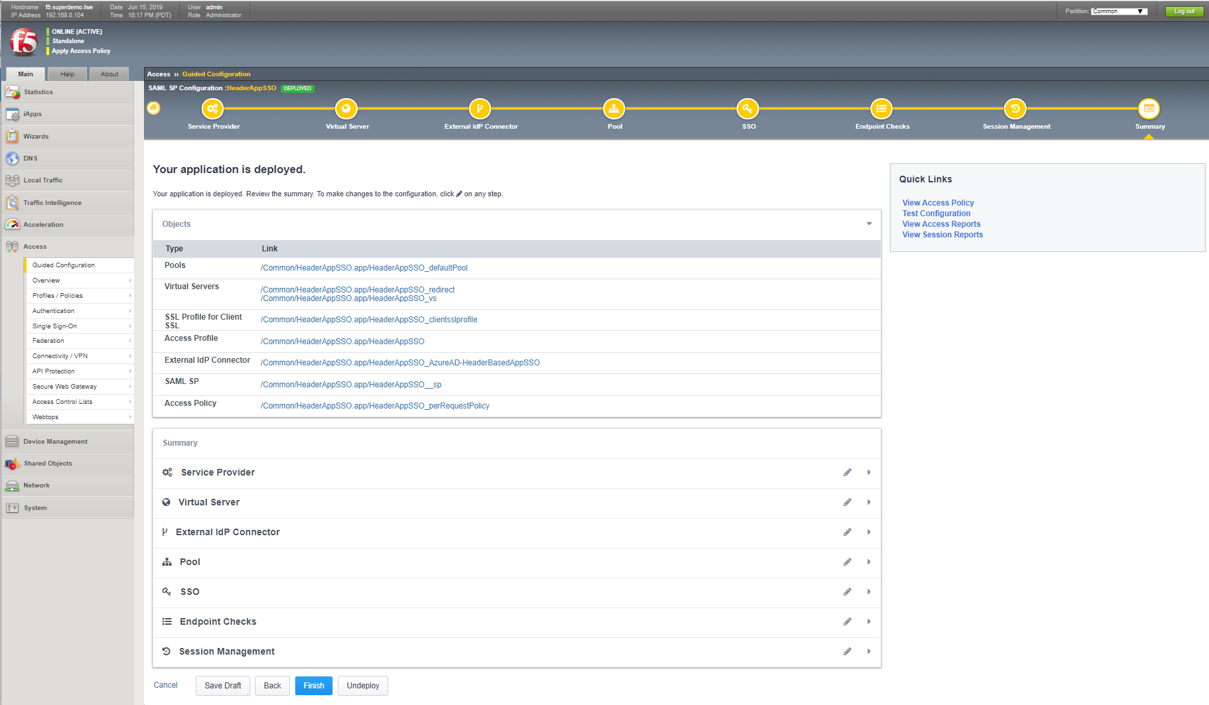

### Testing the Integration

Navigate to the App, [**https://headerapp.superdemo.live**](https://headerapp.superdemo.live), Notice it is redirected to Azure AD

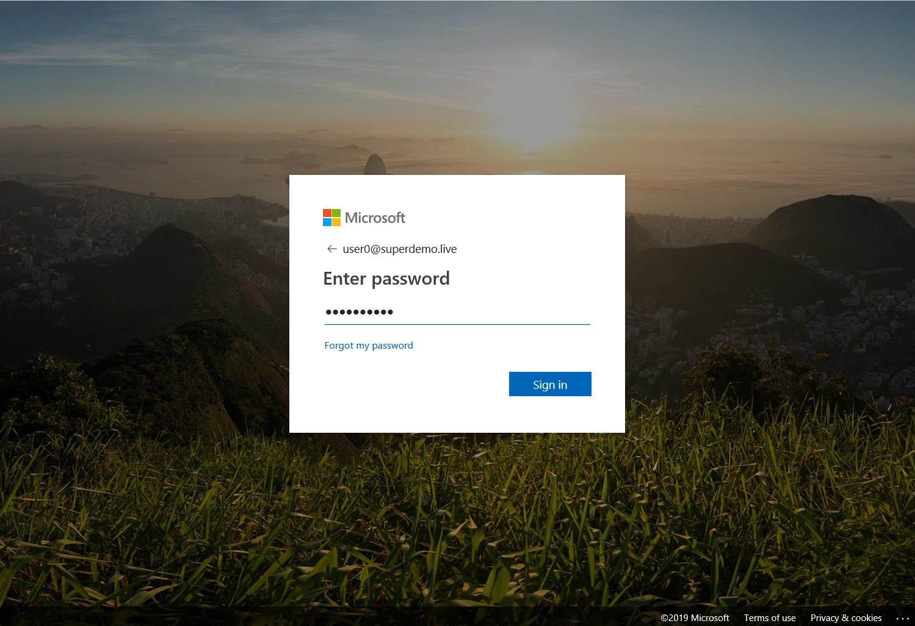

The Application Sample prints all the headers and you can see HTTP_AUTHORIZATION header was inserted with the appropriate value

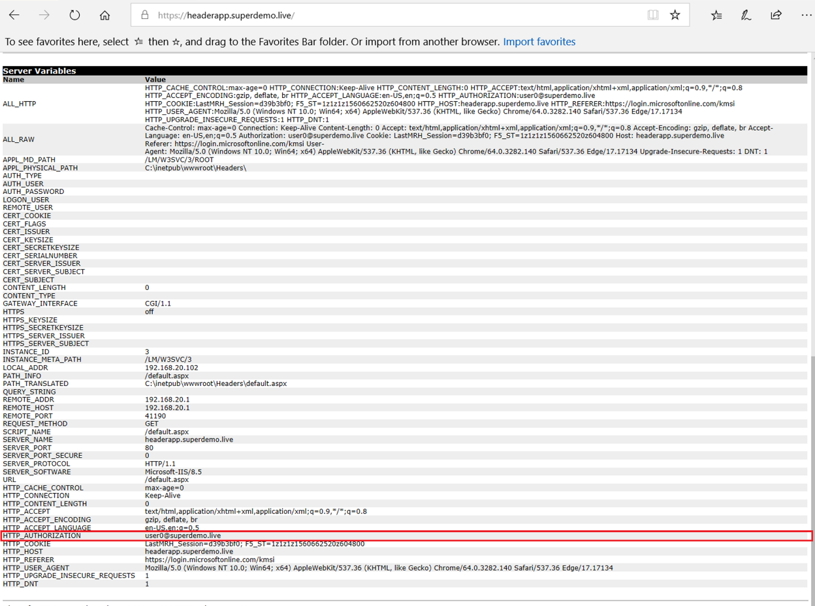

Alternatively, you can simply access the Application from myapps.microsoft.com Portal.

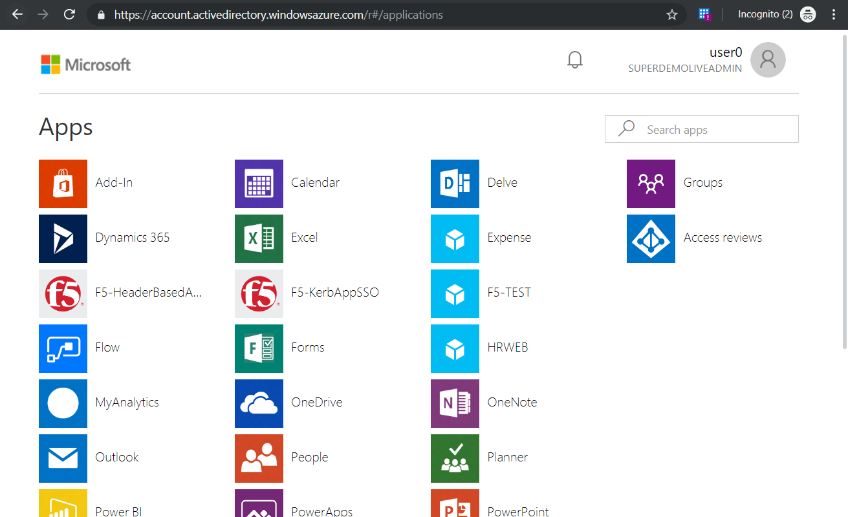

## Kerberos Application

### Setting up Azure Active Directory Integration

Select Enterprise Application Blade and Choose Non-gallery Application

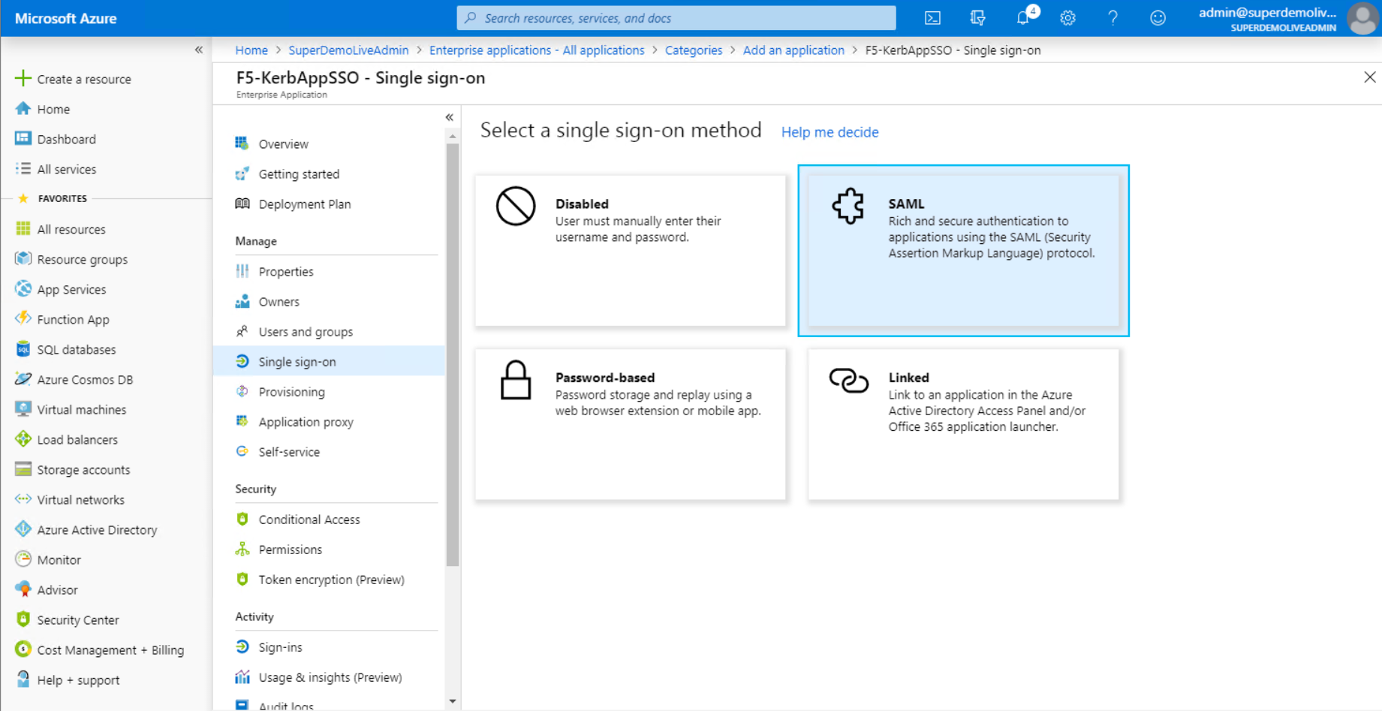

Complete the Basic SAML Configuration Section

Specify the Identifier (Entity ID) and Reply URL, in our example <https://kerbapp.superdemol.live>

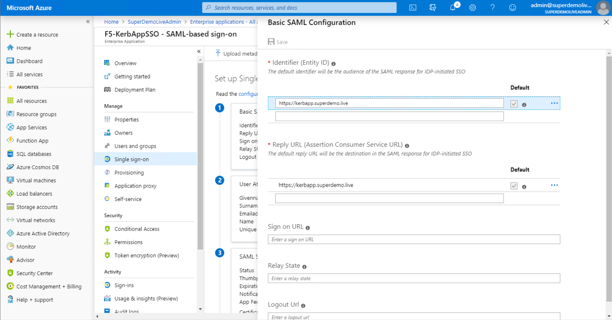

Download the Federation Metadata XML and the Certificate (Base64)

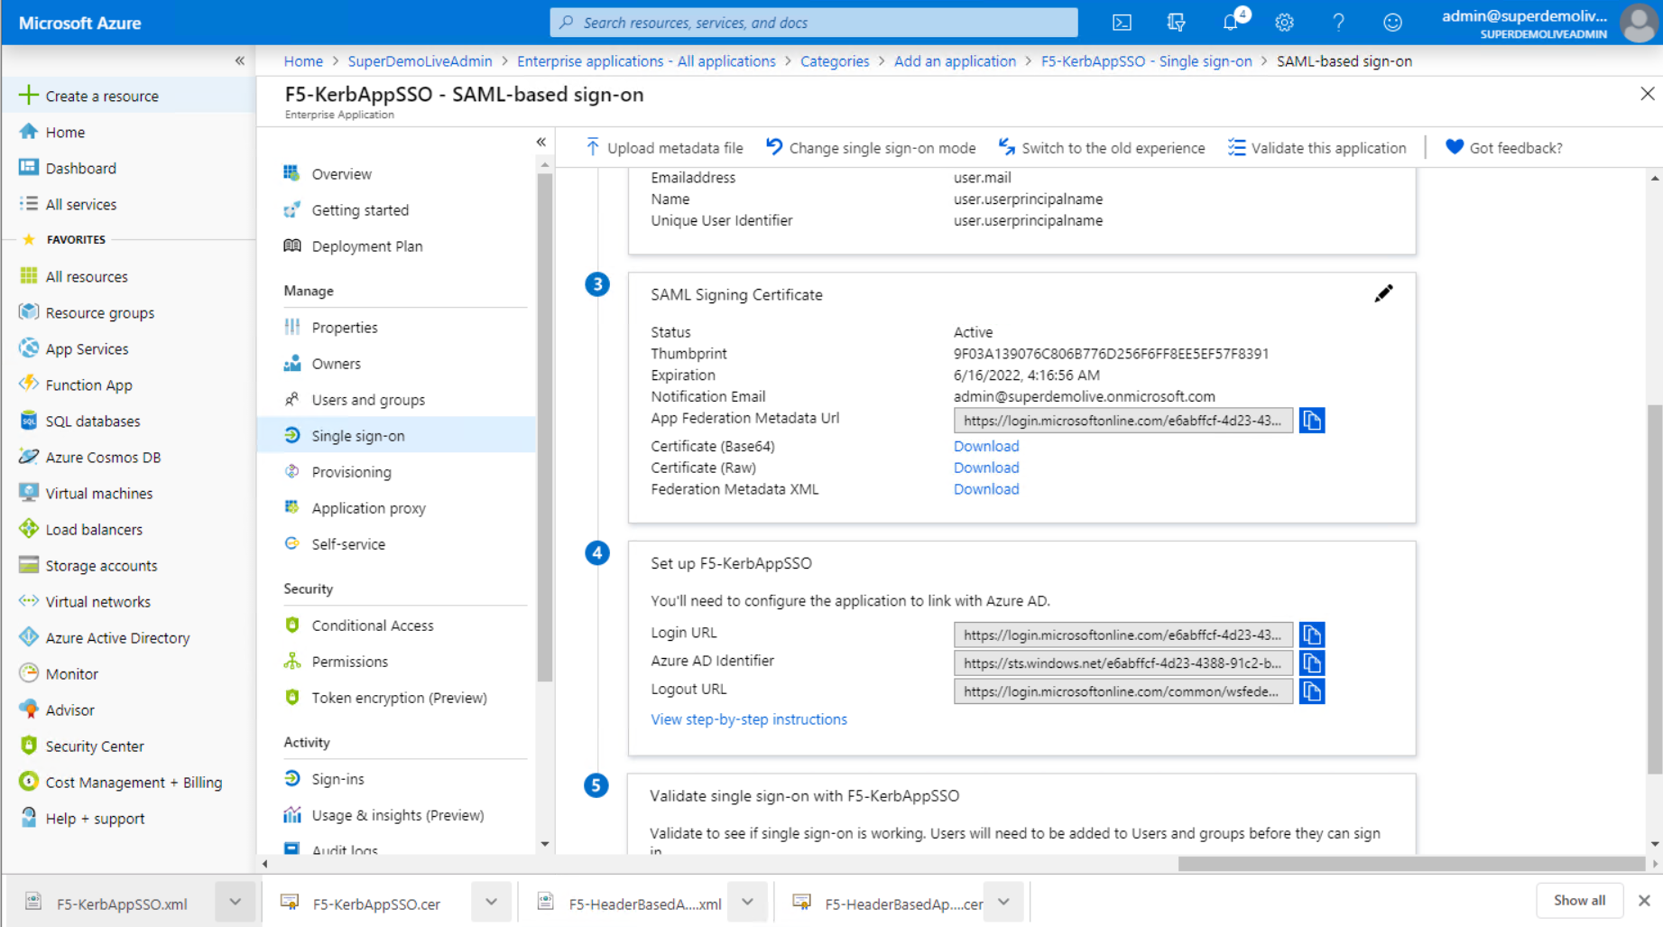

Navigate to the Users and Groups and Specify the users entitled for the Applications.

Doing this step at this point ensures you can test SSO once its configured on the F5 BIG-IP

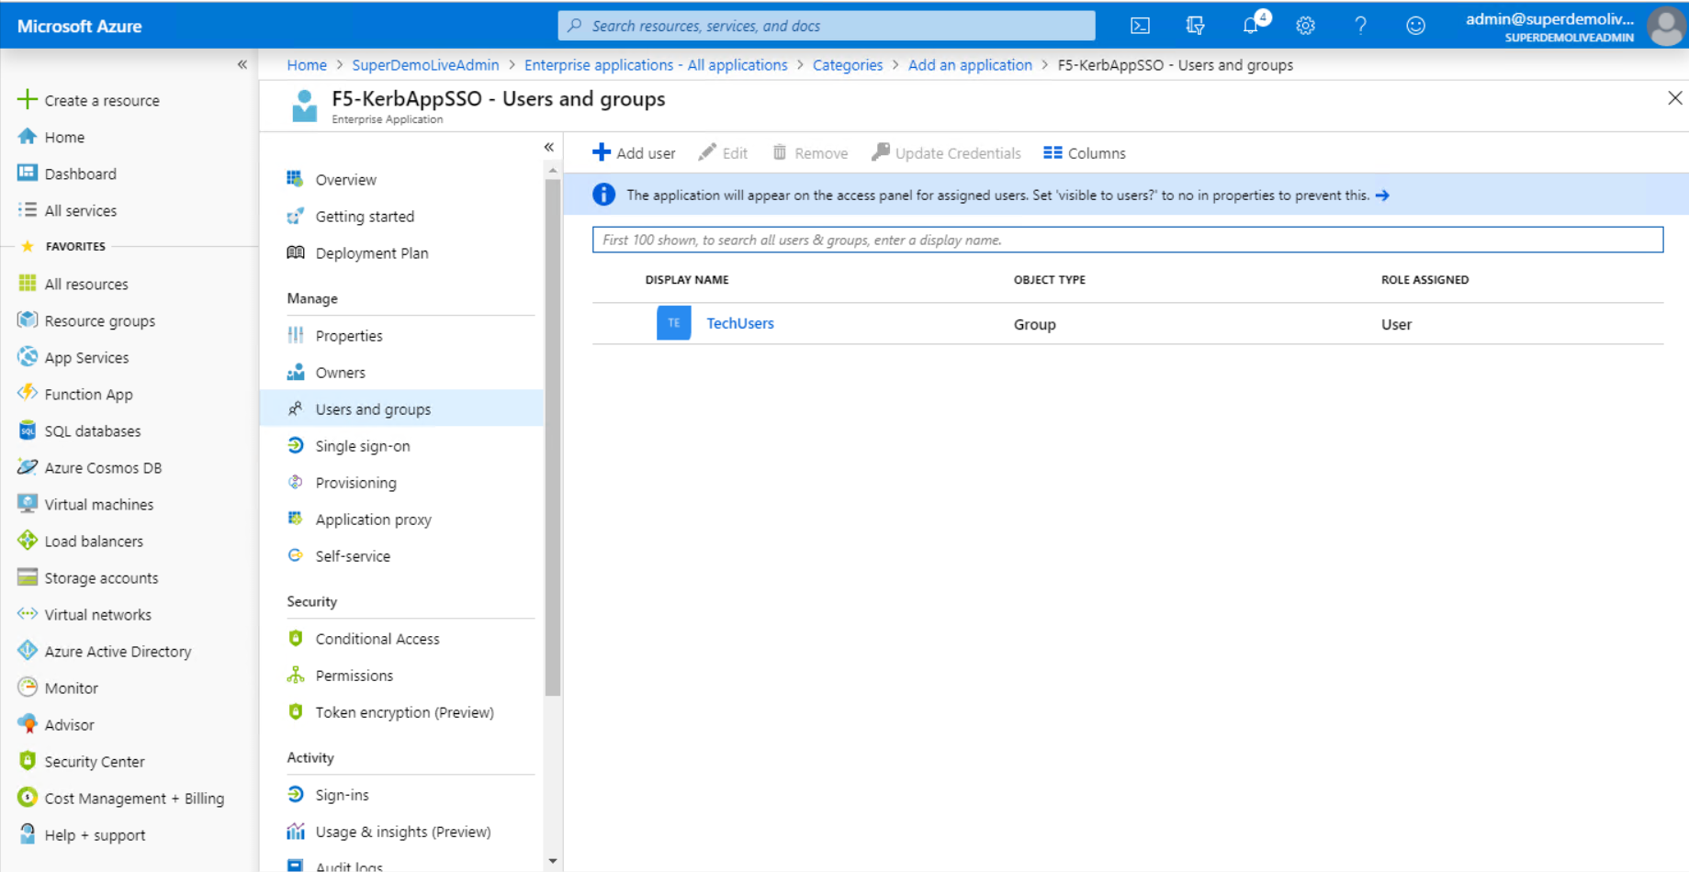

### Configuring F5 BIG-IP

You will need to import the Metadata Certificate into the F5 which will be used later in the setup process. Navigate to System > Certificate Management > Traffic Certificate Management > SSL Certificate List. Select **Import** from the right-hand corner.

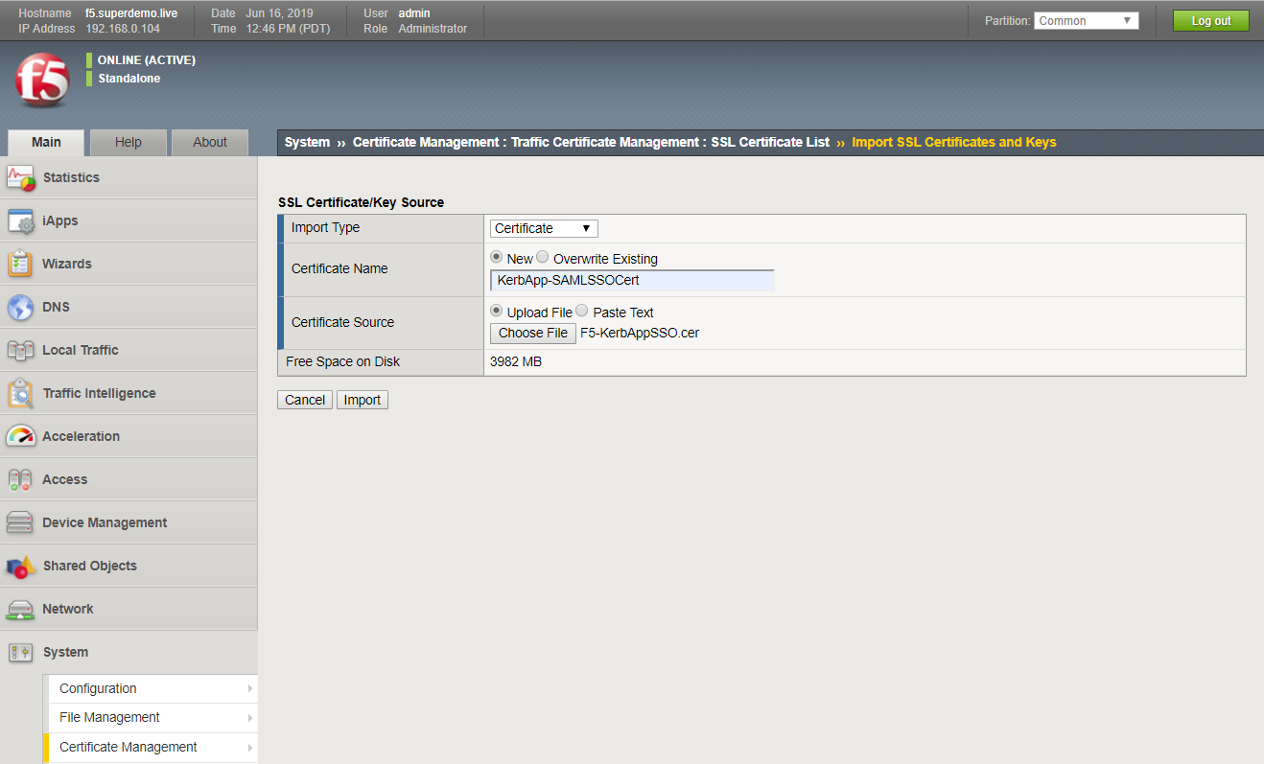

Additionally, you will need an SSL Certificate for the HostName (**Kerbapp.superdemo.live**), in our example I am using a Wildcard Certificate.



We will use the Guided Experience to setup the Azure AD Federation and Application Access.

Go to – F5 BIG-IP and select Access > Guided Configuration > Federation > SAML Service Provider, and then click **Next**.

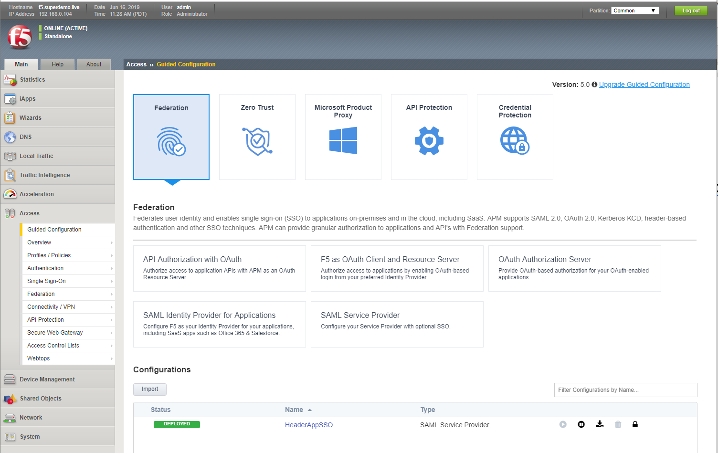

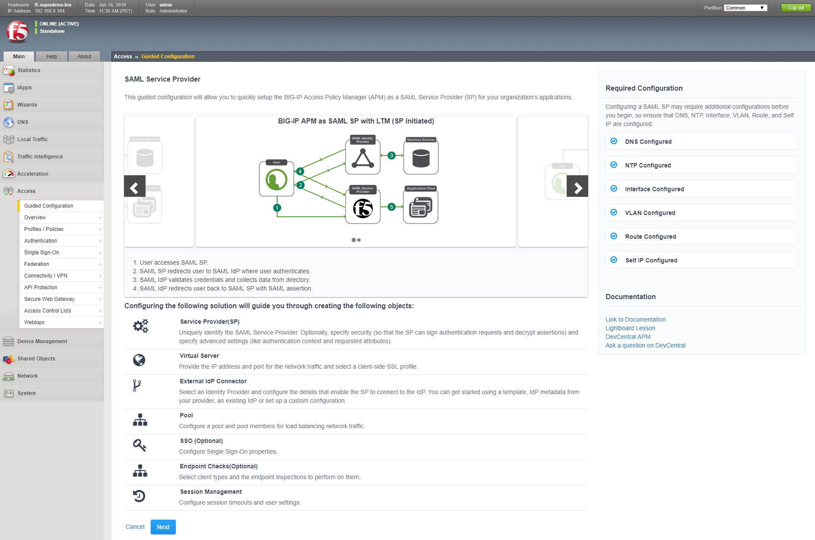

Select **Next** to begin configuration. Provide a name for the configuration and specify the EntityID (same as what you configured on the Azure AD Application Configuration) and the entity host name. Accept the remaining default entries and select and then click **Save & Next.**

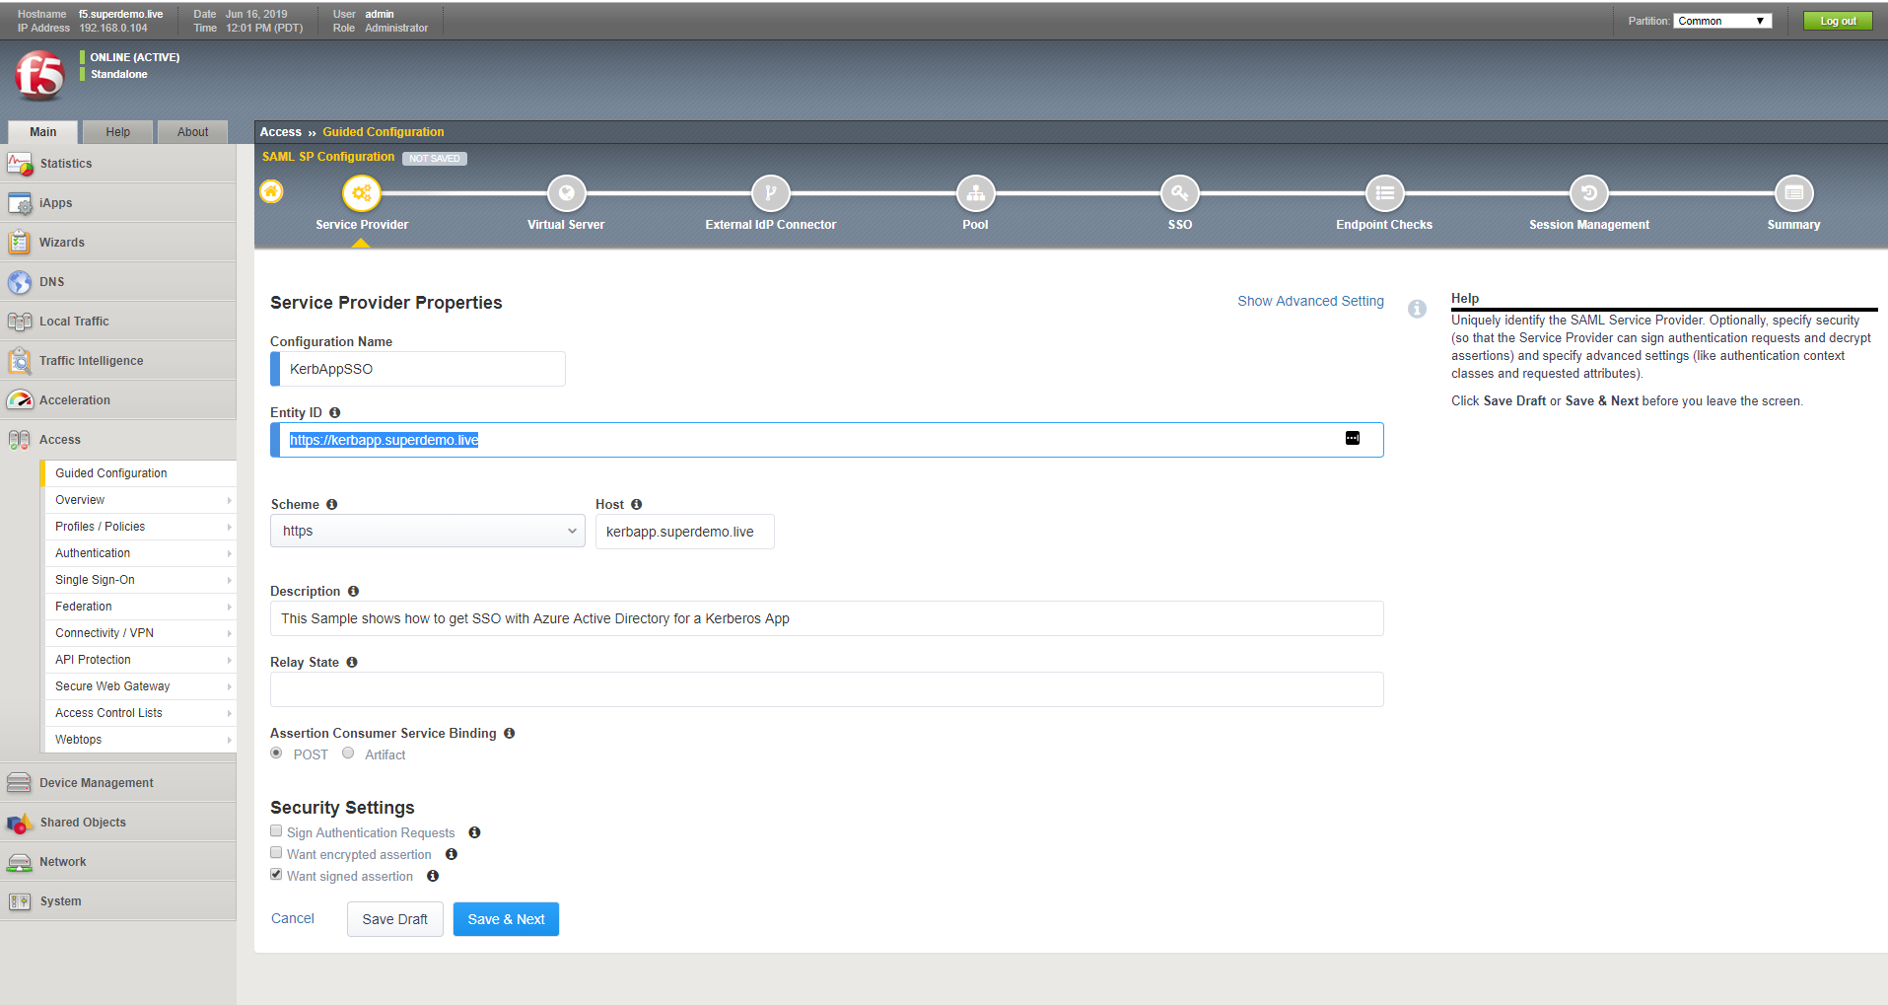

Create a new Virtual Server. Specify the external IP address to be associated with the Entity ID., The Redirect Port configuration is optional. For the Client SSL Profile, select **Create new** and choose the previously uploaded application certificate, (the wild card certificate in this example) and the associated key, and then click **Save & Next**.

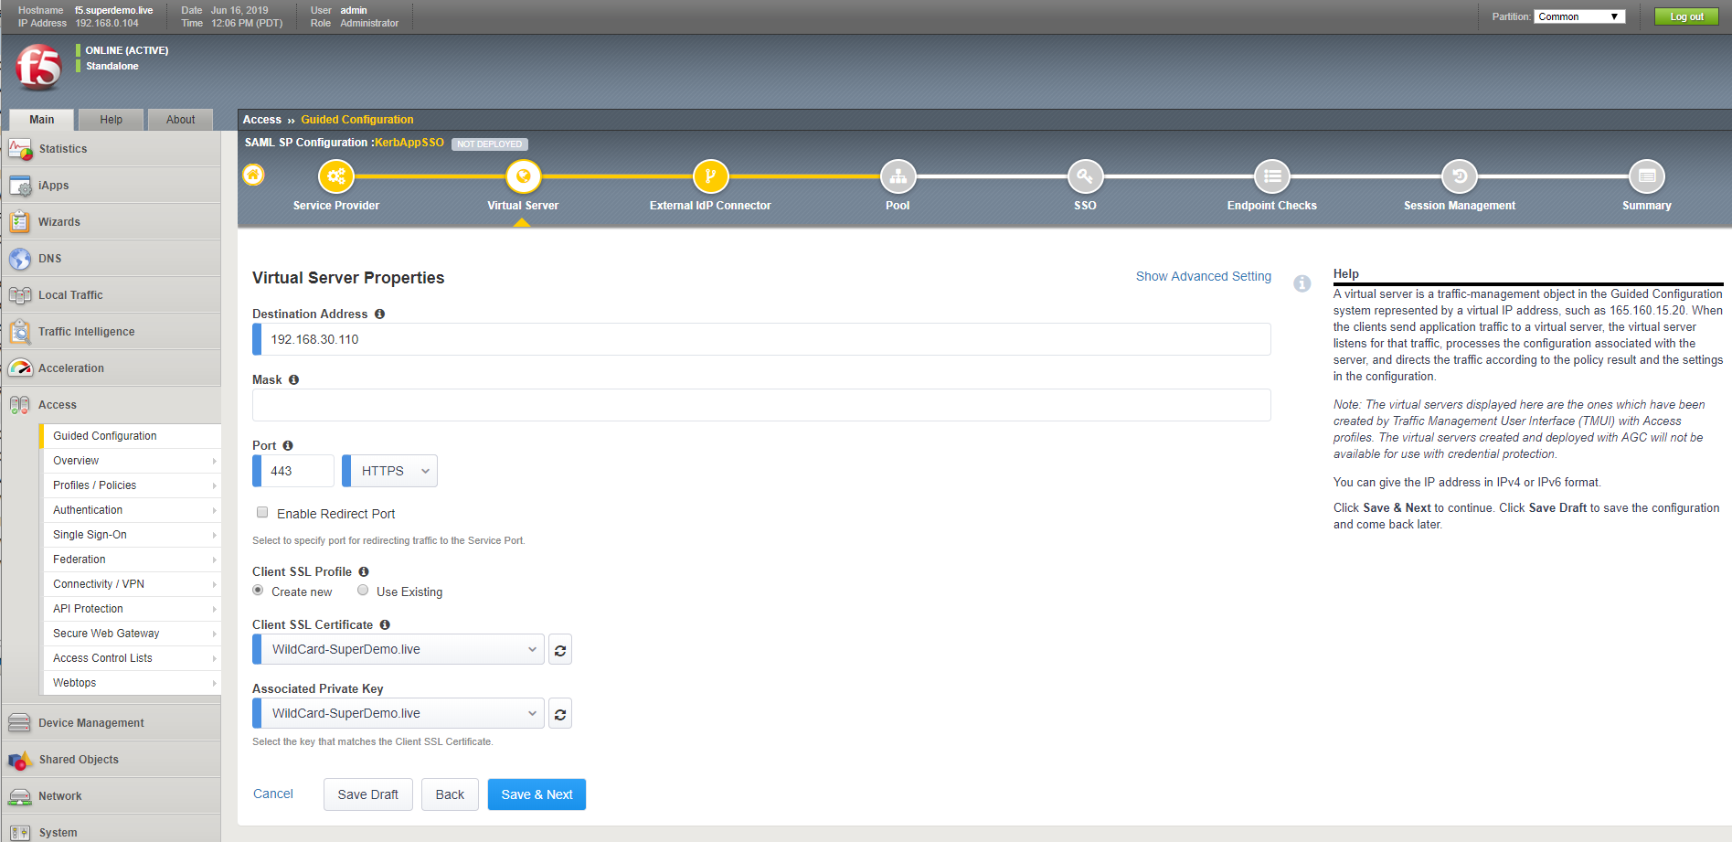

On the External Identity Provider screen, select **Metadata** for the configuration method. Choose upload the configuration metadata and specify a new name for SAML IDP connector, specify the Federation Certificate that was uploaded earlier, and then click **Save & Next**

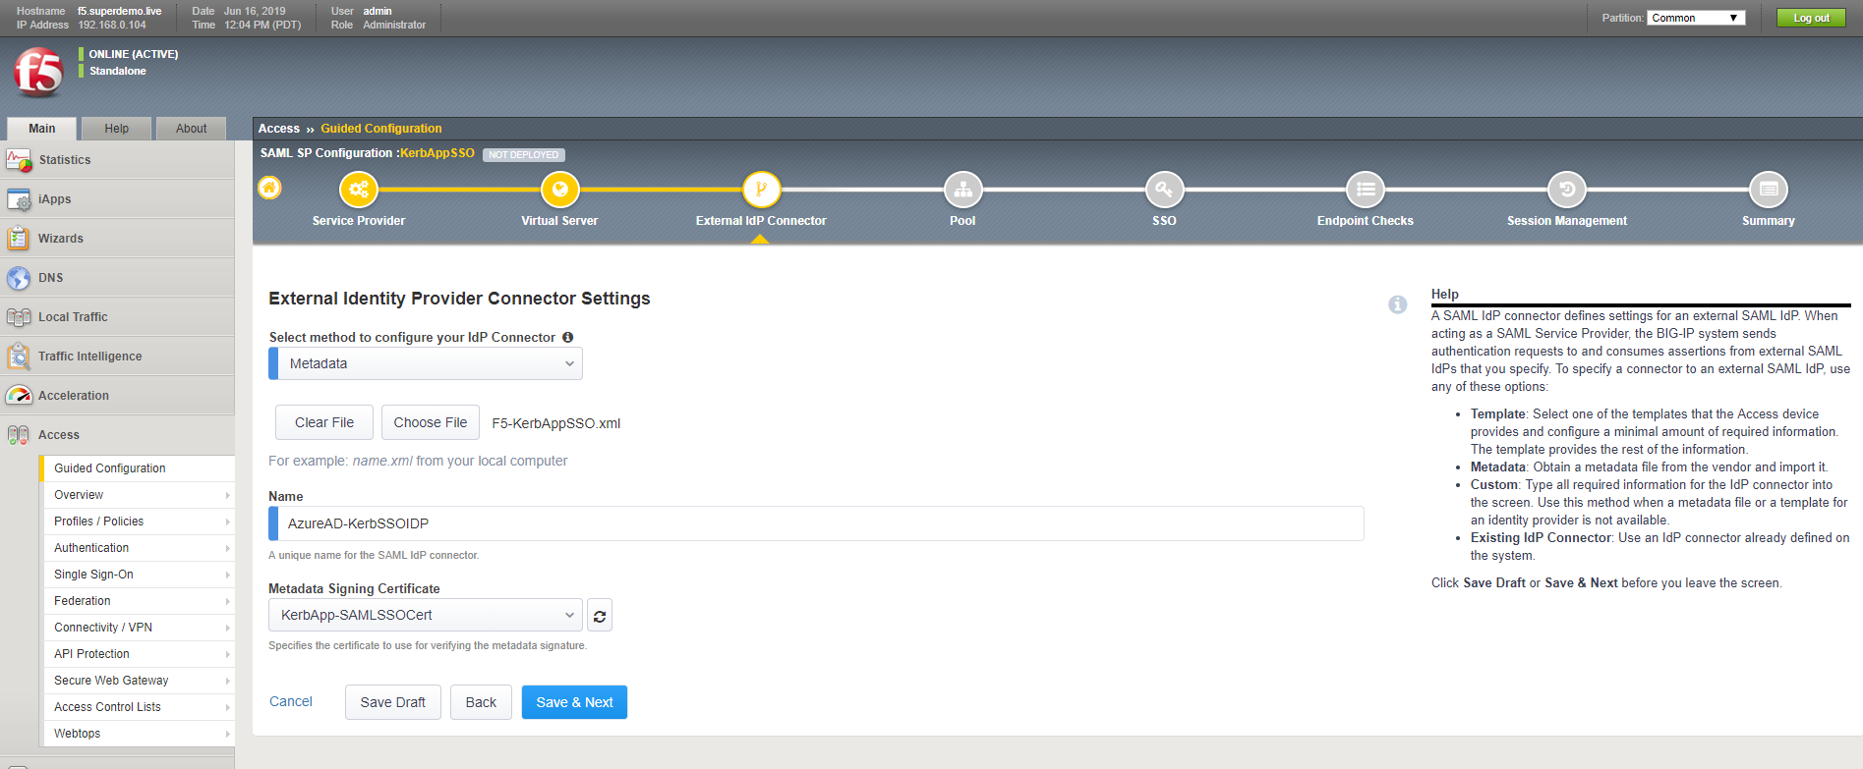

Create a new backend application pool. Specify the IP Address(s) of the backend application server(s), and then click **Save & Next.**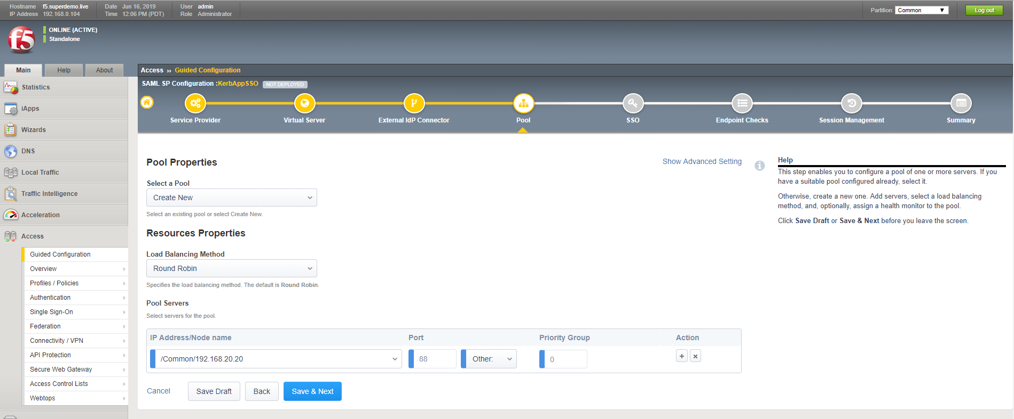

On the Single Sign-On Settings screen, select **Enable Single Sign-On**, **Kerberos** for the Sign-on Type and select Show **Advanced Setting**. The request needs to be created in [user@domain.suffix](mailto:user@domain.suffix). For Username Source, specify ‘session.saml.last.attr.name.http://schemas.xmlsoap.org/ws/2005/05/identity/claims/givenname‘. Provide the credentials, (including Kerberos Realm and KDC address) for AD service account that will handle delegation. Select and enable **UPN Support**, and then click **Save & Next.** Refer Appendix for complete list of variables and values.

**Note: Account Name Is the F5 Delegation Account Created ( Check [F5 Documentation](https://support.f5.com/csp/article/K43063049))**

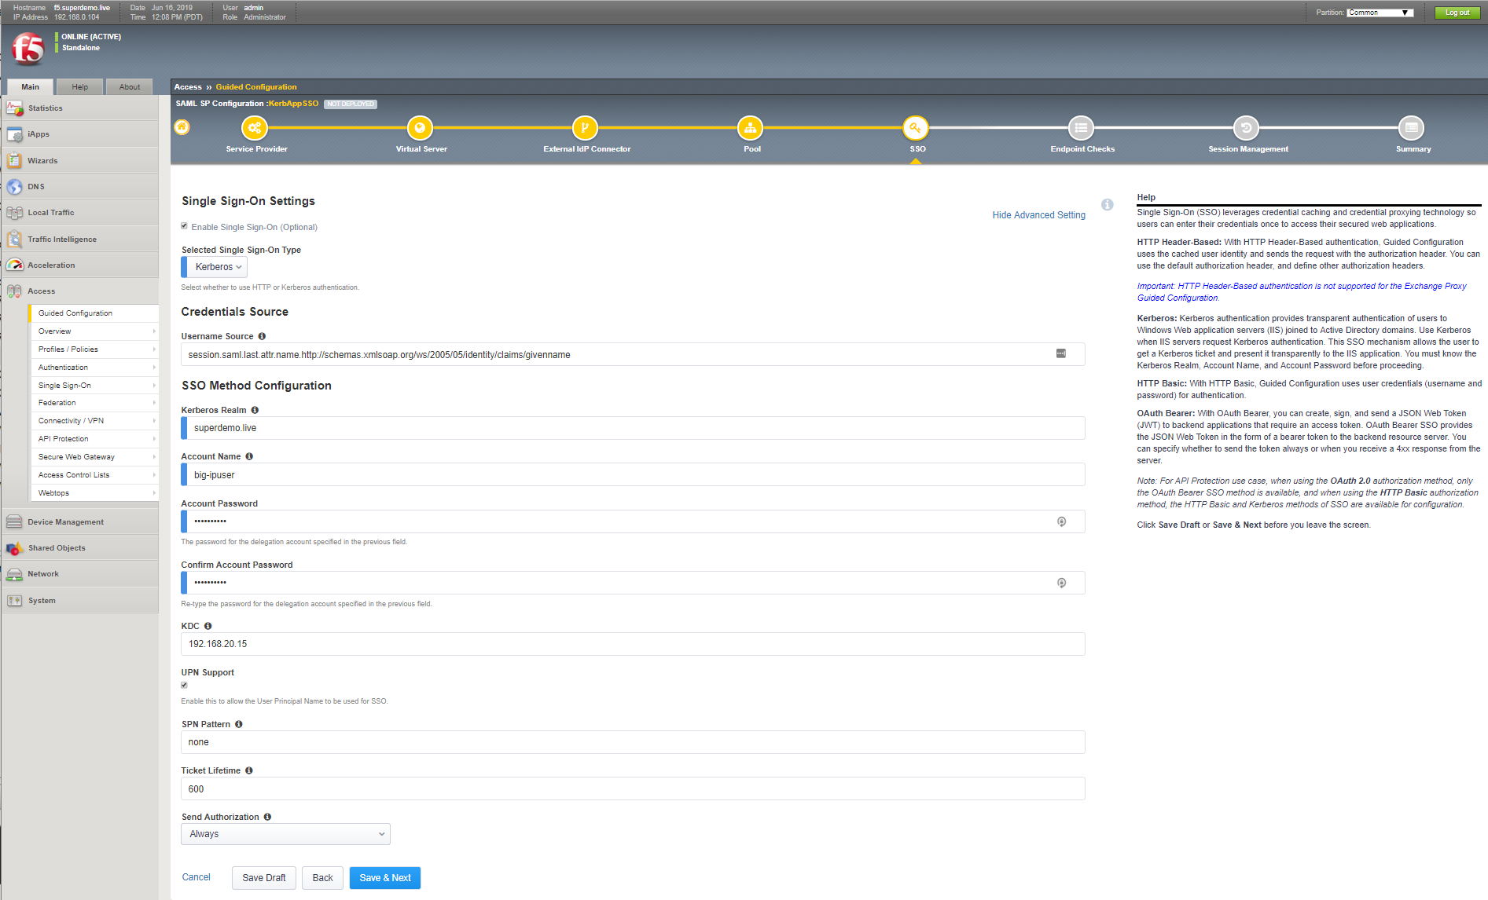

For purposes of this guidance, we will skip endpoint checks. Refer to F5 documentation for details. On screen, select **Save & Next.**

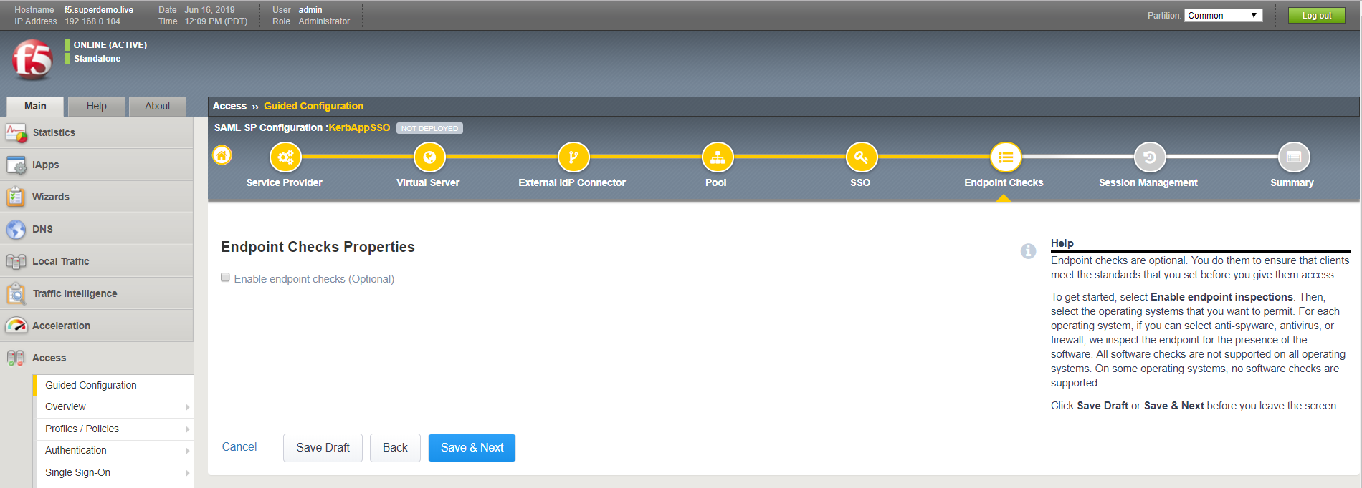

On the Timeout Settings screen, accept the defaults and click **Save & Next.** Consult F5 documentation for details regarding SAML session management settings.

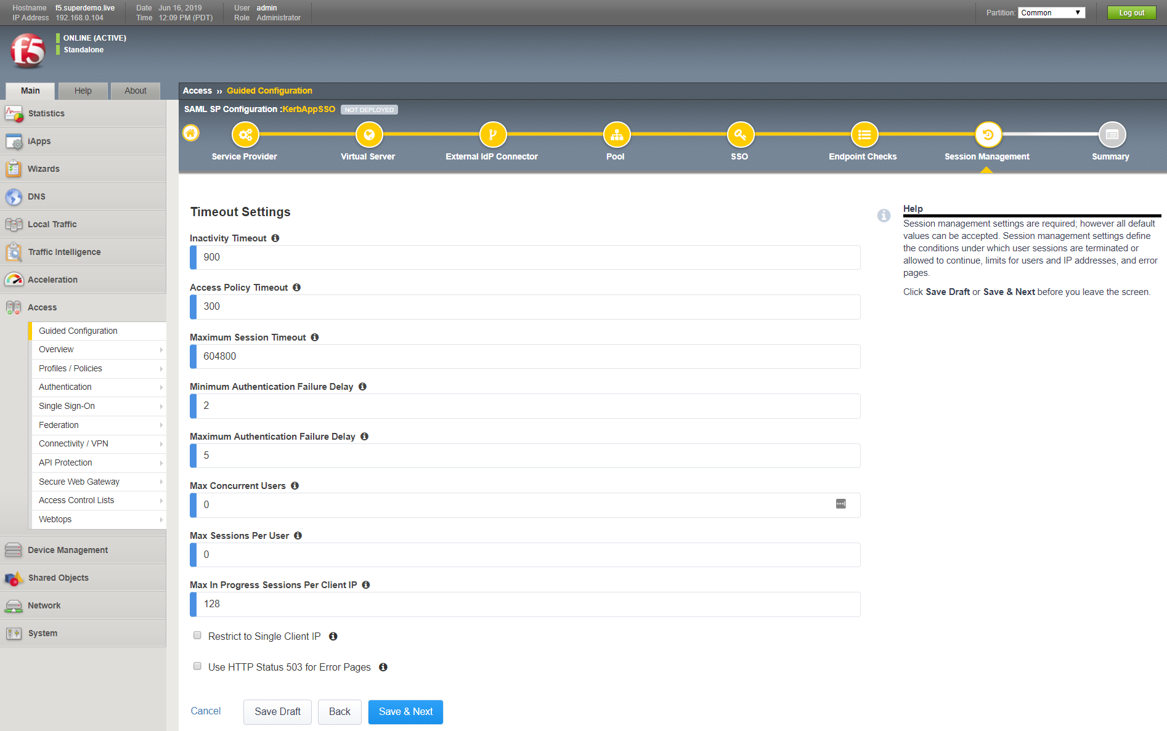

Review the summary screen and select ‘Deploy’ to configure the BIG-IP.

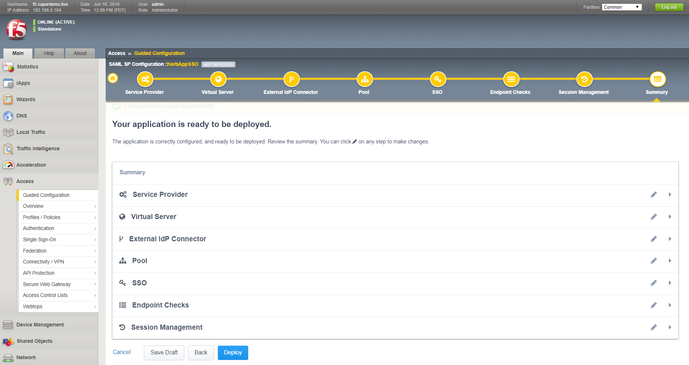

Once the application has been click on **Finish**.

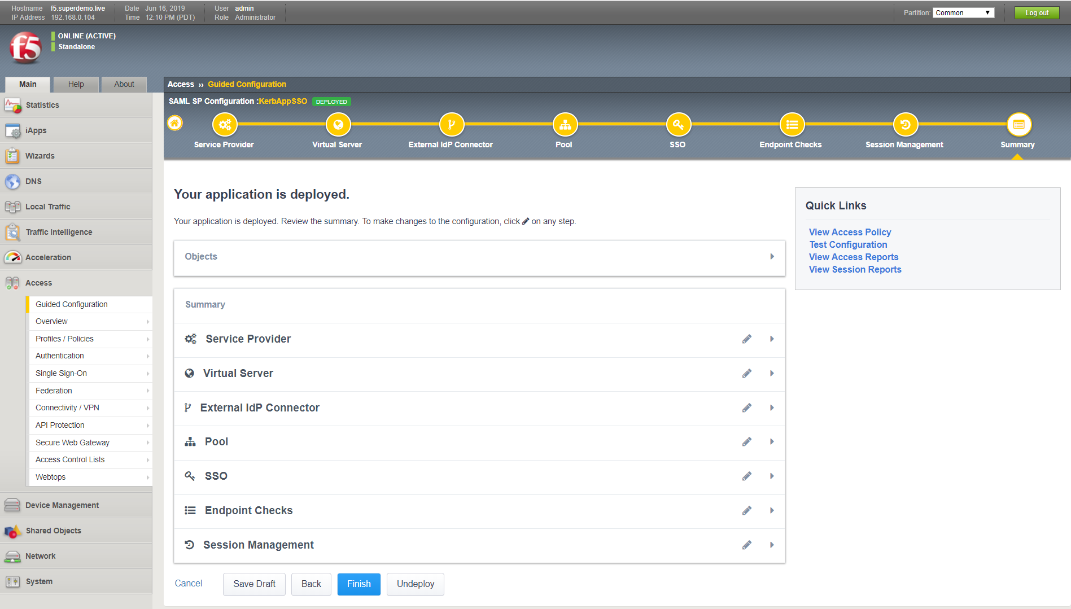

### Testing the Integration

Navigate to the <https://kerbapp.superdemo.live>, you will be redirected to Azure Active Directory login Page

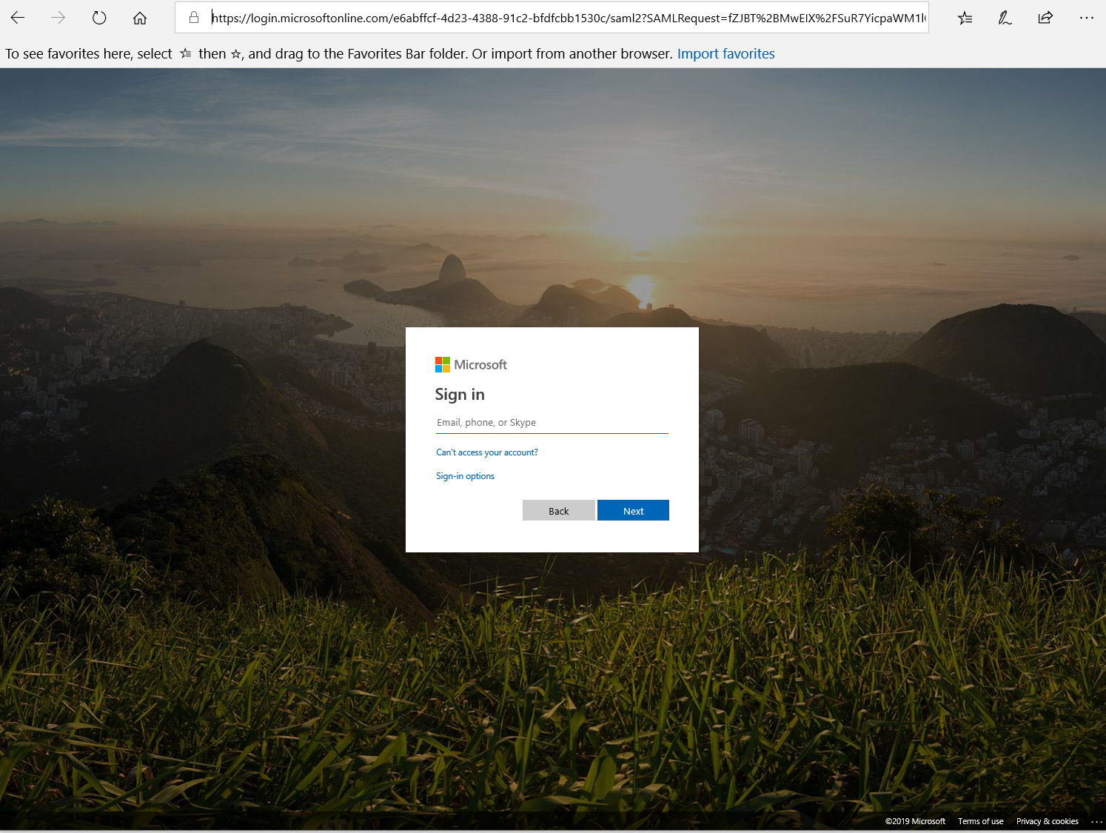

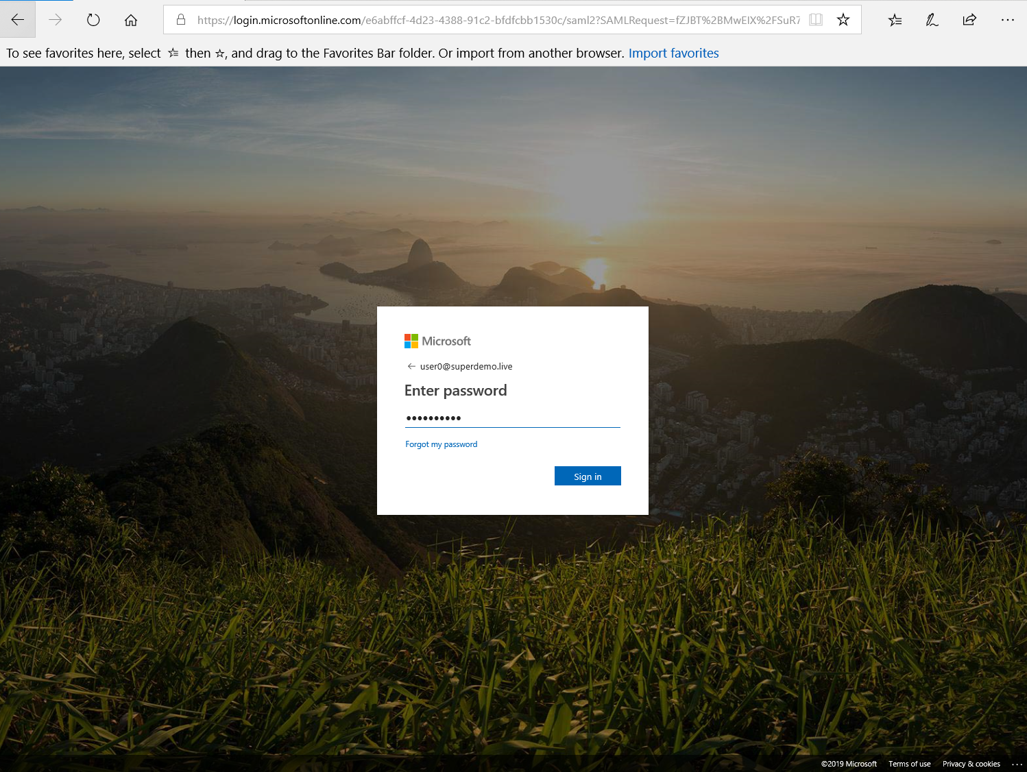

The Application successfully logs you on and the User is successfully identified.



Alternatively, you can simply access the Application from myapps.microsoft.com Portal.



# Advanced Configuration

## Kerberos SSO Configuration

Reference

<https://techdocs.f5.com/kb/en-us/products/big-ip_apm/manuals/product/apm-authentication-single-sign-on-11-5-0/2.html>

### Configuring an Active Directory AAA server

You configure an Active Directory AAA server in Access Policy Manager (APM) to specify domain controllers and credentials for APM to use for authenticating users.

1. On the Main tab, click **Access Policy** > **AAA Servers** > **Active Directory**. The Active Directory Servers list screen opens.
2. Click **Create**. The New Server properties screen opens.
3. In the **Name** field, type a unique name for the authentication server.
4. In the **Domain Name** field, type the name of the Windows domain.
5. For the **Server Connection** setting, select one of these options:

* Select **Use Pool** to set up high availability for the AAA server.
* Select **Direct** to set up the AAA server for standalone functionality.

1. If you selected **Direct**, type a name in the **Domain Controller** field.
2. If you selected **Use Pool**, configure the pool:

* Type a name in the **Domain Controller Pool Name** field.
* Specify the **Domain Controllers** in the pool by typing the IP address and host name for each, and clicking the **Add** button.
* To monitor the health of the AAA server, you have the option of selecting a health monitor: only the **gateway_icmp** monitor is appropriate in this case; you can select it from the **Server Pool Monitor** list.

1. In the **Admin Name** field, type a is case-sensitive name for an administrator who has Active Directory administrative permissions. APM uses the information in the **Admin Name** and **Admin Password** fields for AD Query. If Active Directory is configured for anonymous queries, you do not need to provide an Admin Name. Otherwise, APM needs an account with sufficient privilege to bind to an Active Directory server, fetch user group information, and fetch Active Directory password policies to support password-related functionality. (APM must fetch password policies, for example, if you select the Prompt user to change password before expiration option in an AD Query action.) If you do not provide Admin account information in this configuration, APM uses the user account to fetch information. This works if the user account has sufficient privilege.
2. In the **Admin Password** field, type the administrator password associated with the Domain Name.
3. In the **Verify Admin Password** field, retype the administrator password associated with the **Domain Name** setting.
4. In the **Group Cache Lifetime** field, type the number of days. The default lifetime is 30 days.
5. In the **Password Security Object Cache Lifetime** field, type the number of days. The default lifetime is 30 days.
6. From the **Kerberos Preauthentication Encryption Type** list, select an encryption type. The default is **None**. If you specify an encryption type, the BIG-IP system includes Kerberos preauthentication data within the first authentication service request (AS-REQ) packet.
7. In the **Timeout** field, type a timeout interval (in seconds) for the AAA server. (This setting is optional.)
8. Click **Finished**. The new server displays on the list.

This adds the new Active Directory server to the Active Directory Servers list.

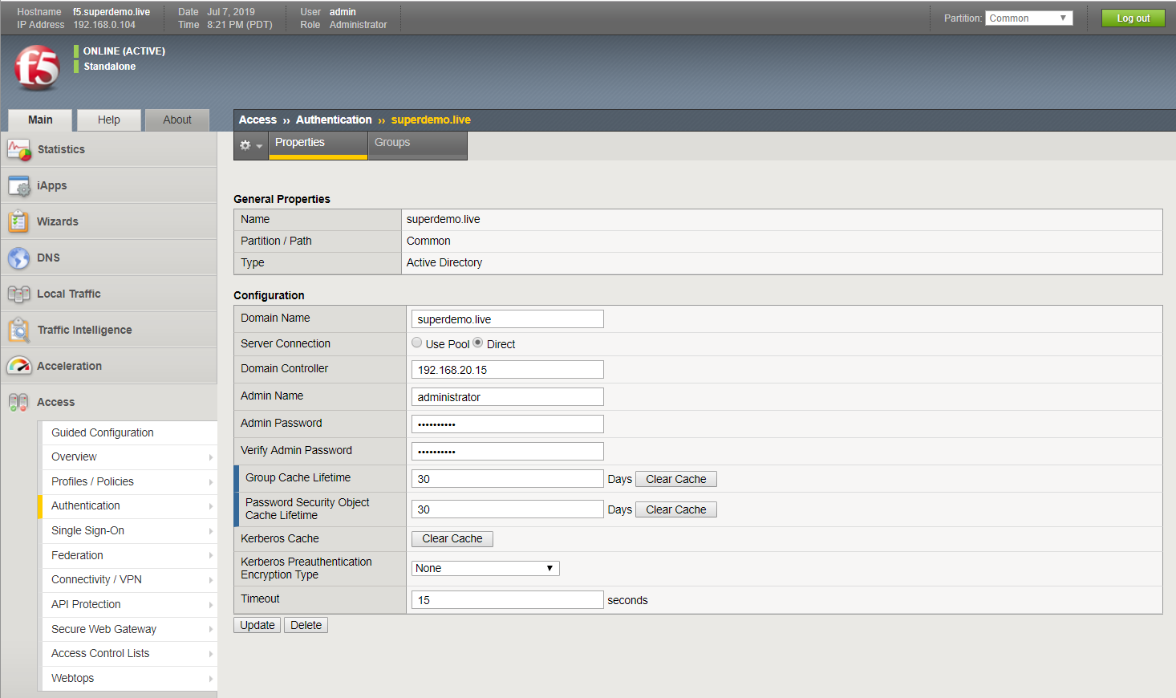

### SAML Configuration

#### Part 1: Setting up Azure Active Directory Integration

Select Enterprise Application Blade and Choose Non-gallery Application



Specify SAML as the Single Sign-on method



Complete the Basic SAML Configuration Section

Specify the Identifier (Entity ID) and Reply URL, in our example <https://kerbapp200.superdemol.live>



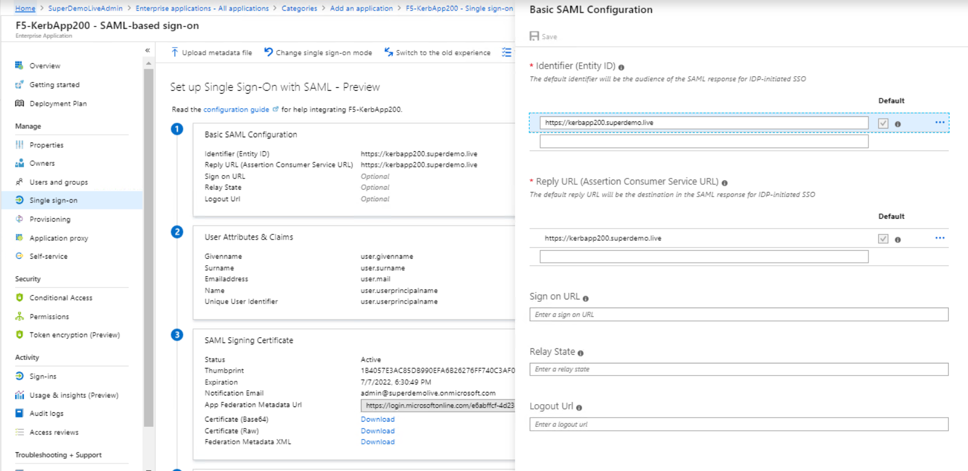

Download the Federation Metadata XML and the Certificate (Base64)

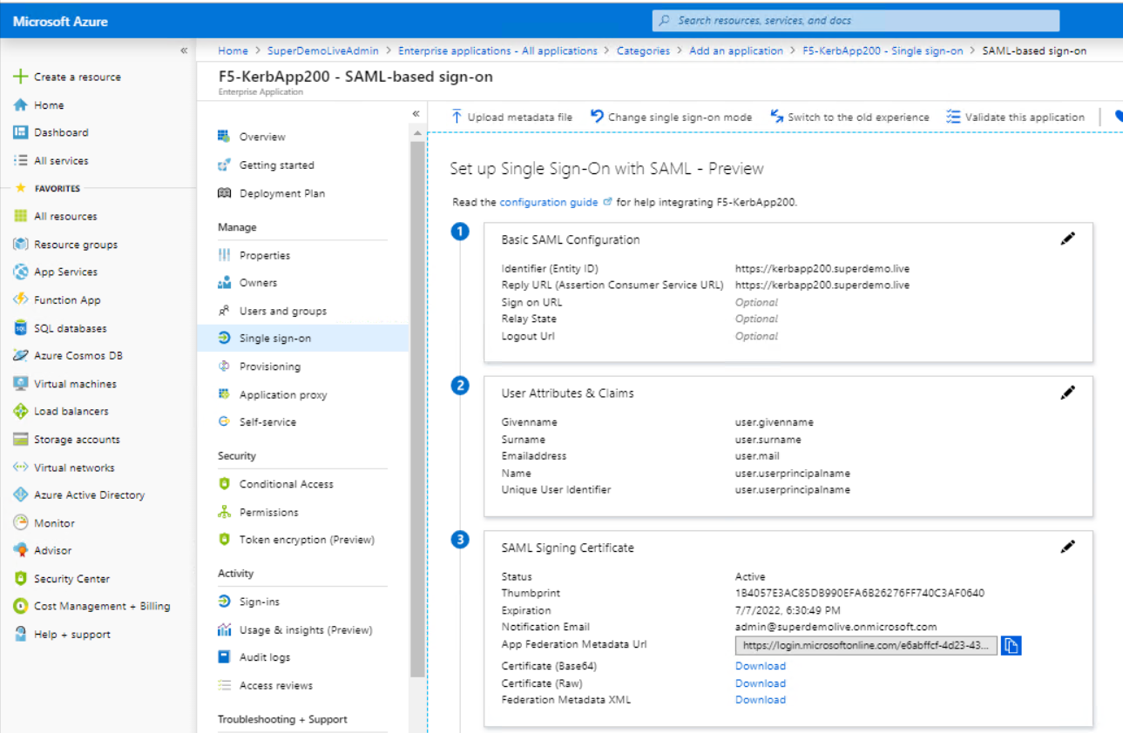

Navigate to the Users and Groups and Specify the users entitled for the Applications.

Doing this step at this point ensures you can test SSO once its configured on the F5 BIG-IP



#### **Part 2: Note the following details from the XML file (Optional only for reference )**

* entityID
* SingleLogoutService Location
* SingleSignOnService Location

Example:

* entityID="**https://sts.windows.net/4995b495-fbd2-4b47-8bb4-1604a38342e6/**"
* SingleLogoutService Location="**https://login.microsoftonline.com/4995b495-fbd2-4b47-8bb4-1604a38342e6/saml2**"
* SingleSignOnService Location=[**https://login.microsoftonline.com/4995b495-fbd2-4b47-8bb4-1604a38342e6/saml2**](https://login.microsoftonline.com/4995b495-fbd2-4b47-8bb4-1604a38342e6/saml2)

#### **Part 3: F5 SAML Configuration**

You will need to import the Metadata Certificate into the F5 which will be used later in the setup process. Navigate to System > Certificate Management > Traffic Certificate Management > SSL Certificate List. Select **Import** from the right-hand corner.

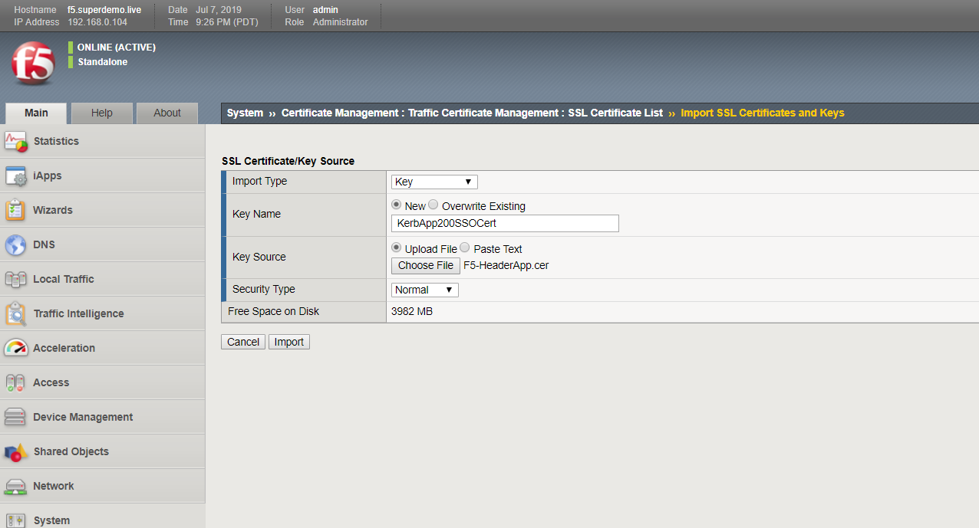

#### **Part 4: F5 SAML SP Configuration**

Setup the SAML IDP:

Navigate to Access > Federation > SAML: Service Provider > External Idp Connectors, and click **Create > From Metadata**.

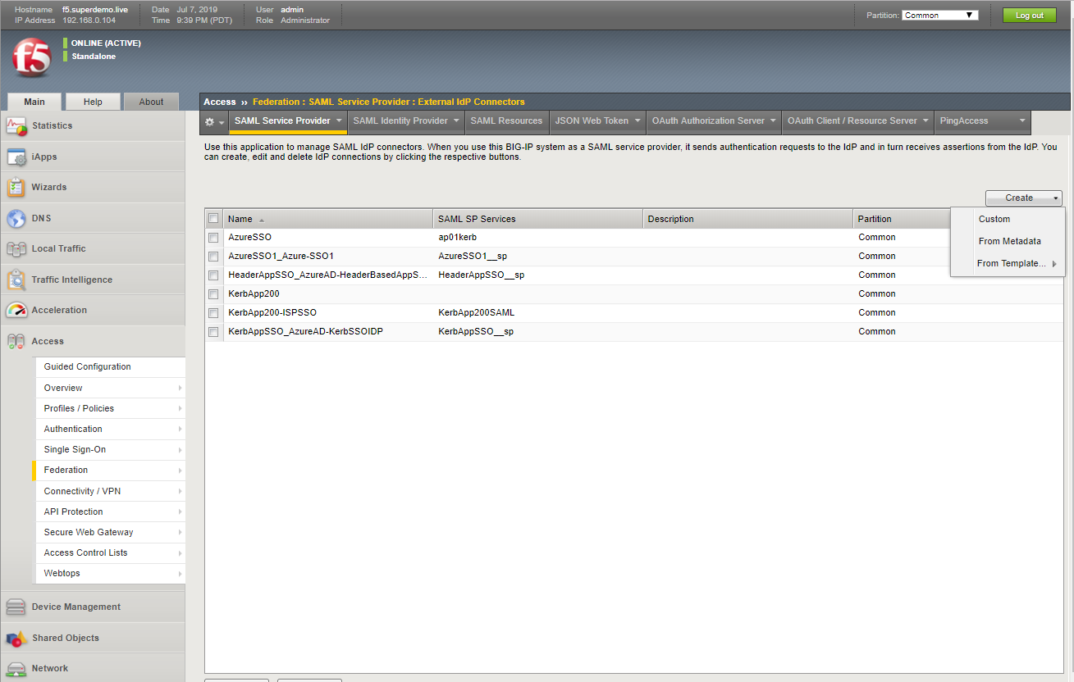

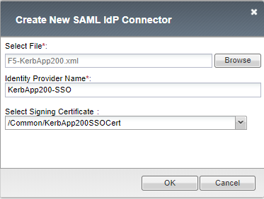

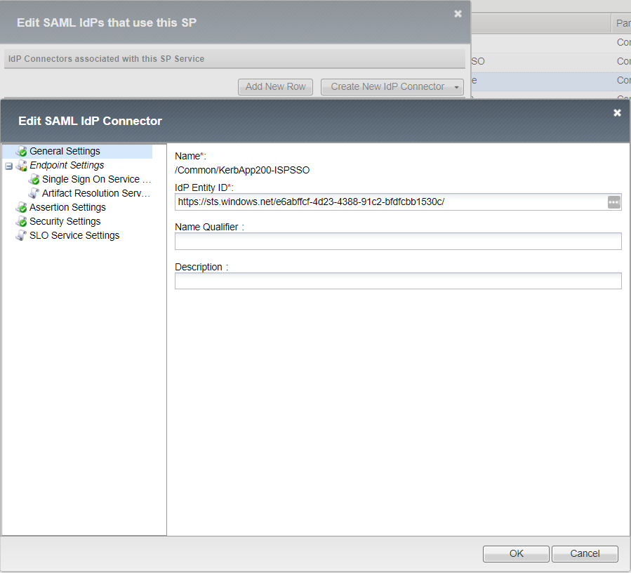

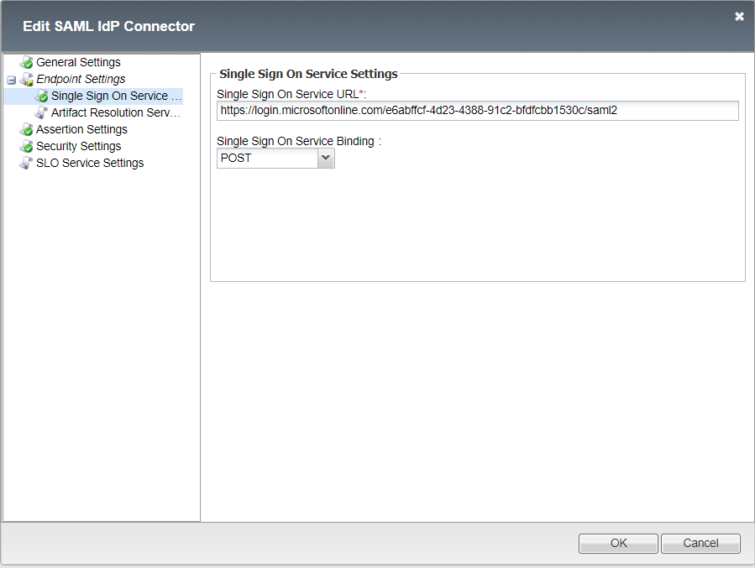

Specify the Certificate uploaded from Task 3

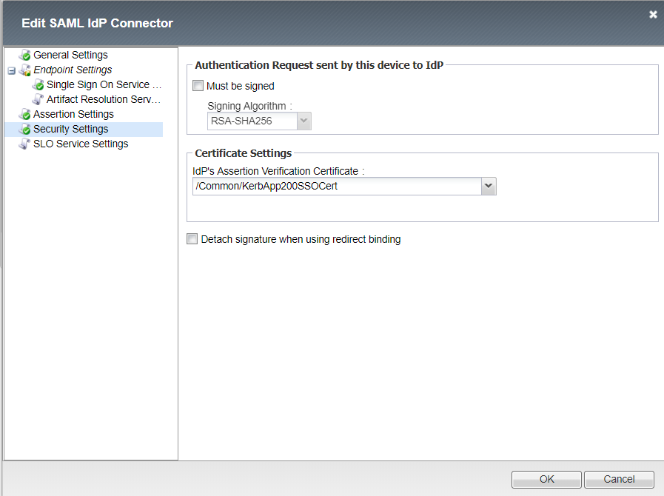

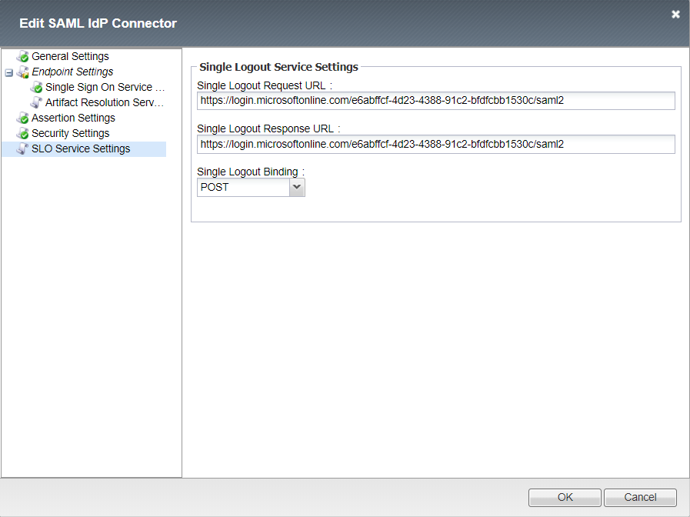

Setup the SAML SP

Navigate to Access > Federation > SAML Service Provider > Local SP Services and click **Create**. Complete the following information and click **OK**.

* Name: KerbApp200SAML
* Entity ID*: <https://kerbapp200.superdemo.live>
* SP Name Settings
  + Scheme: https
  + Host: kerbapp200.superdemo.live
  + Description: kerbapp200.superdemo.live

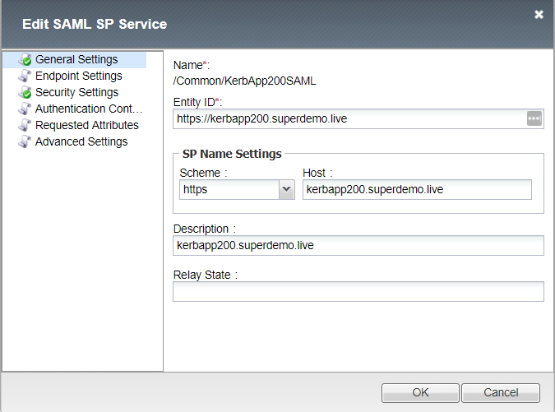

Select the SP Configuration, KerbApp200SAML, and Click **Bind/UnBind IdP Connectors**.

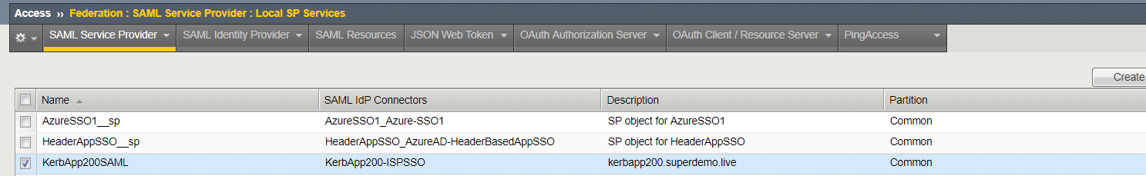



Click on **Add New Row** and Select the **External IdP connector** created in previous step, click **Update**, and then click **OK**.

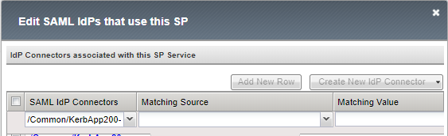

#### **Part 5: Configuring Kerberos SSO**

Navigate to Access > Single Sign-on > Kerberos, complete information and click **Finished**.

**Note:** You will need the Kerberos Delegation Account to be created and specified. Refer KCD Section ( Refer Appendix for Variable References)

* Username Source

session.saml.last.attr.name.http://schemas.xmlsoap.org/ws/2005/05/identity/claims/givenname

* User Realm Source

session.logon.last.domain

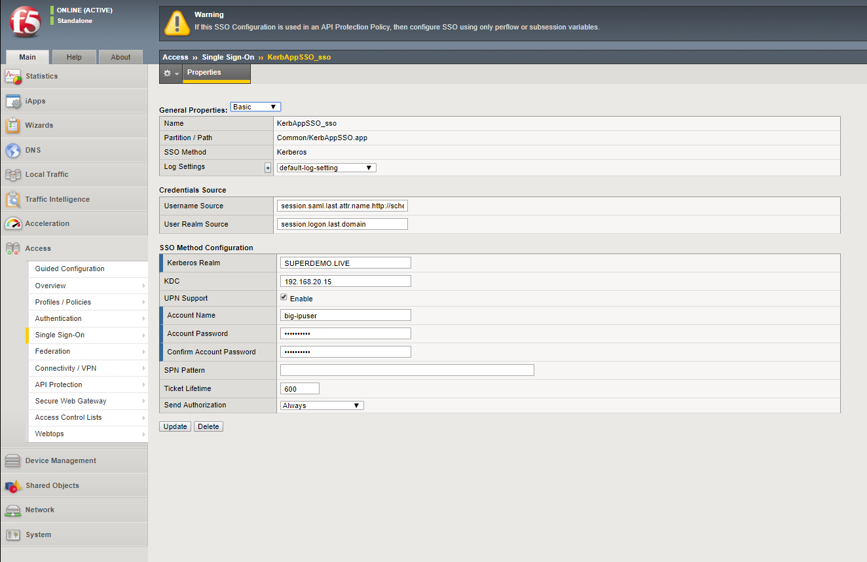

#### **Part 6: Configuring Access Profile**

Navigate to Access > Profile/Policies > Access Profile (per session policies), click **Create**, complete the following information and click **Finished**.

* Name: KerbApp200
* Profile Type: All
* Profile Scope: Profile
* Languages: English

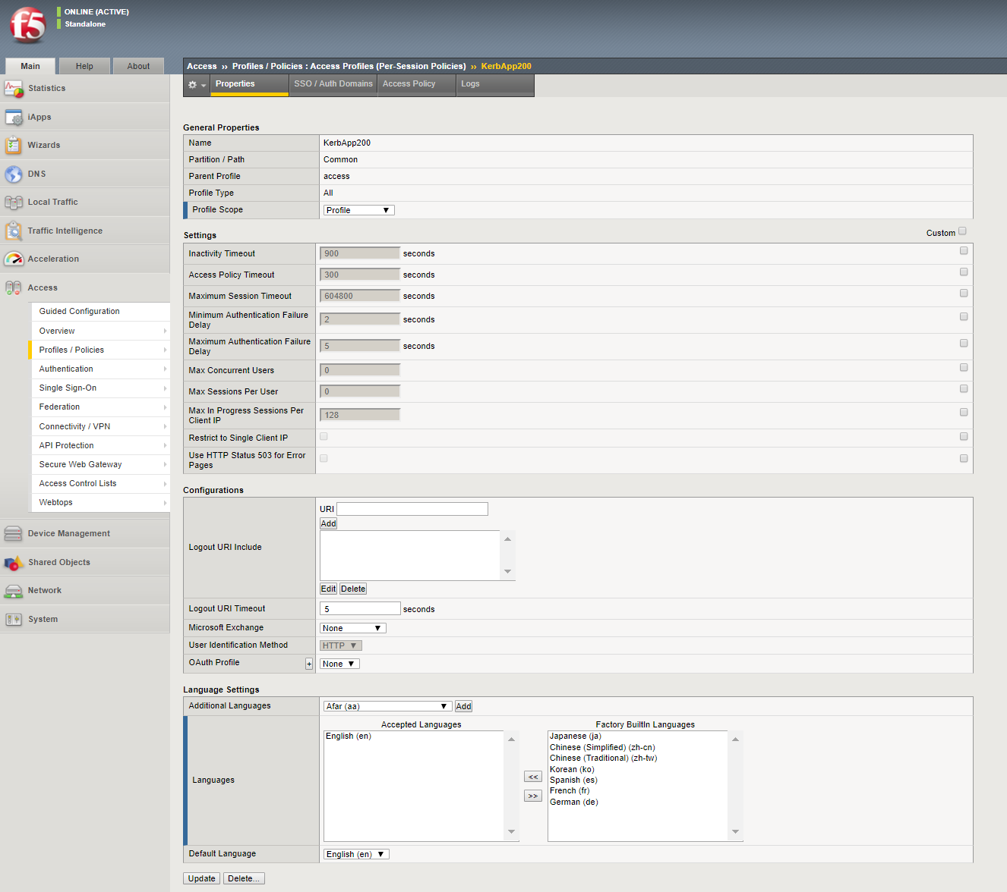

Click on the name, KerbApp200, complete the following information and click **Update**.

* Domain Cookie: superdemo.live
* SSO Configuration: KerAppSSO_sso

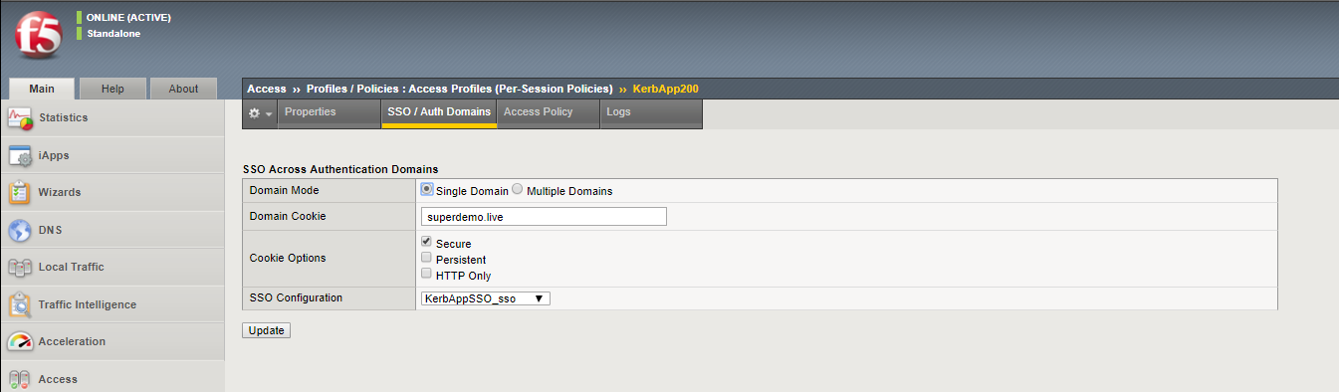

Click **Access Policy** and then click **Edit Access Policy** for Profile “KerbApp200”

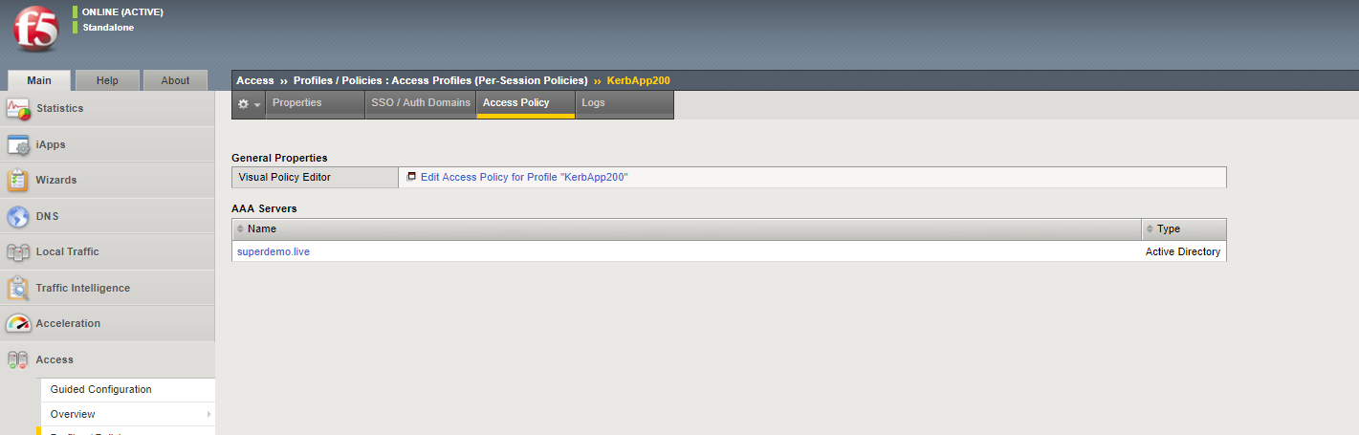

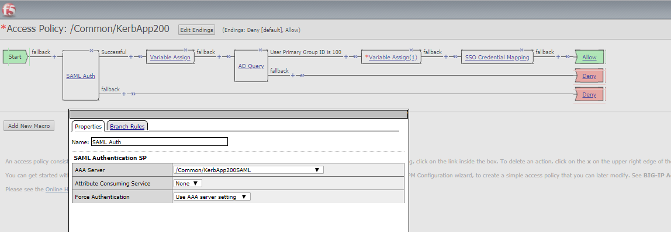

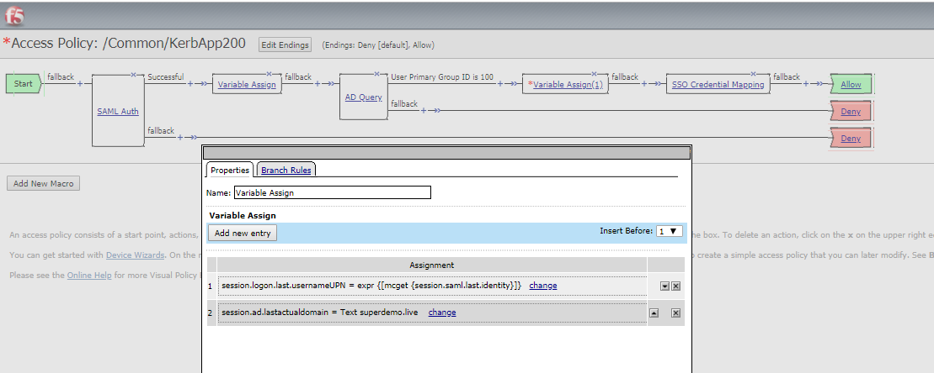

session.logon.last.usernameUPN expr {[mcget {session.saml.last.identity}]}

session.ad.lastactualdomain TEXT superdemo.live

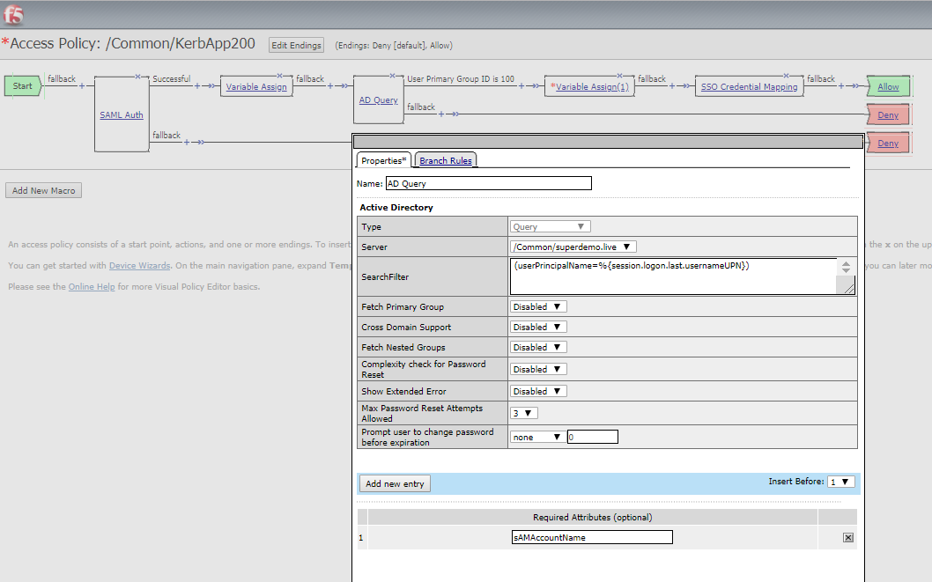

(userPrincipalName=%{session.logon.last.usernameUPN})

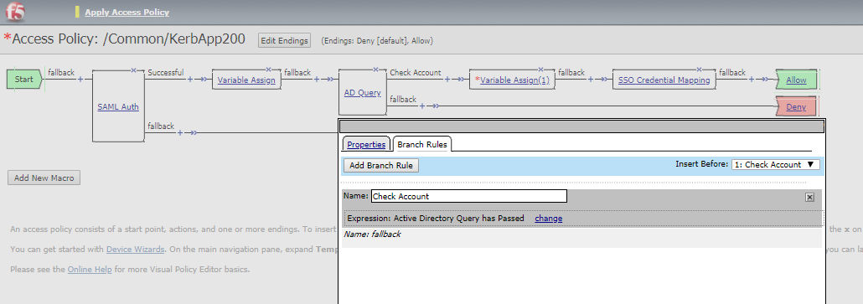

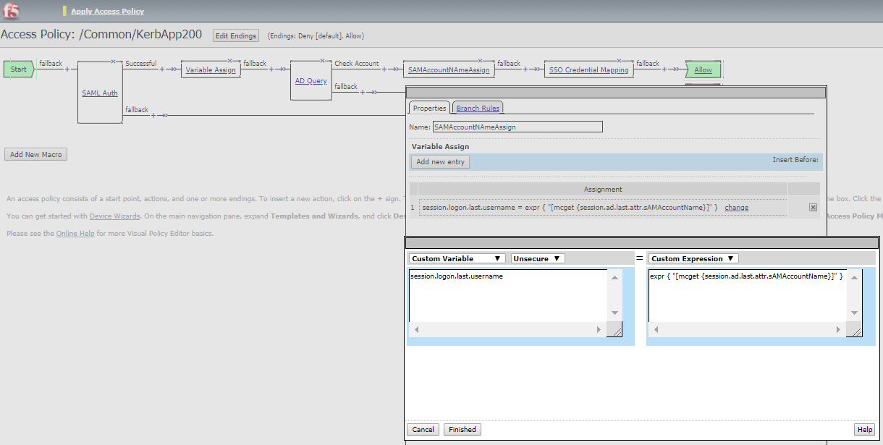

session.logon.last.username expr { "[mcget {session.ad.last.attr.sAMAccountName}]" }

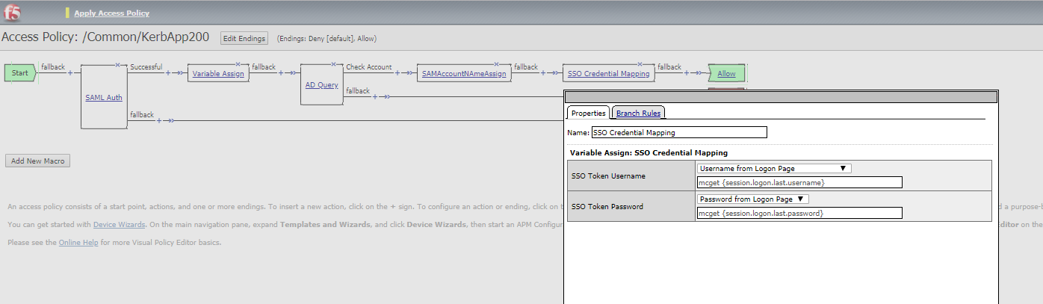

mcget {session.logon.last.username}

mcget {session.logon.last.password}

#### **Part 7: Configuring Application**

Add New Node

Navigate to Local Traffic > Nodes > Node List, click **Create**, complete the following information, and then click **Finished**.

* Name: KerbApp200
* Description: KerbApp200
* Address: 192.168.20.200

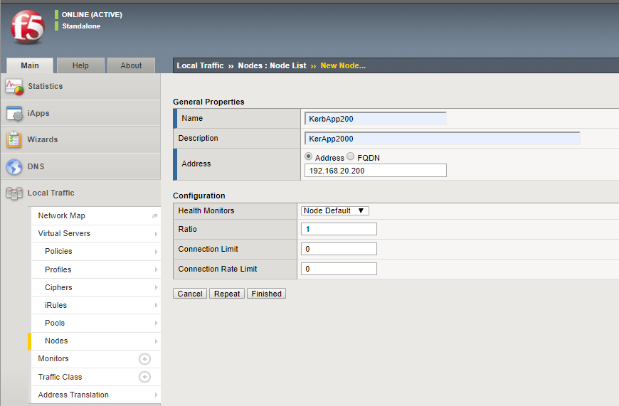

**Create a new Pool**

Navigate to **Local Traffic > Pools > Pool List**, click **Create**, complete the following information and click **Finished**.

* Name: KerbApp200-Pool
* Description: KerbApp200-Pool
* Health Monitors: http
* Address: 192.168.20.200
* Service Port: 81

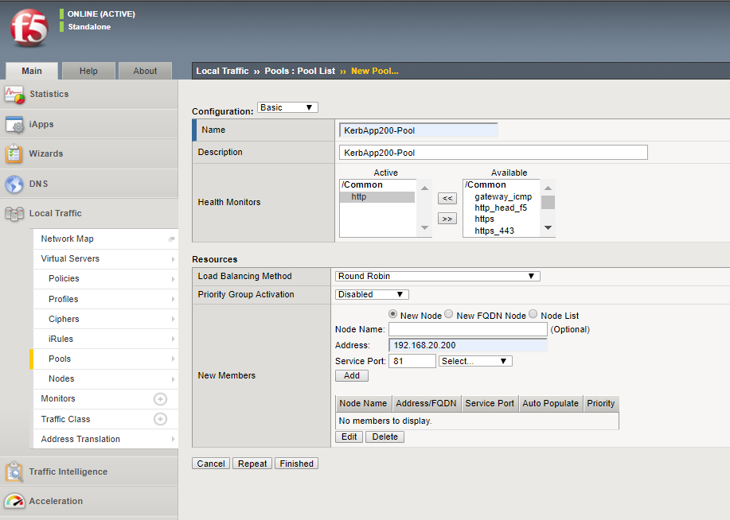

**Virtual Server**

Navigate to Loca**l Traffic > Virtual Servers > Virtual Server List >** +, complete the following information and click **Finished**.

* Name: KerbApp200
* Destination Address/Mask: Host 192.168.30.200
* Service Port: Port 443 HTTPS
* Access Profile: KerbApp200
* Specify the Access Profile Created in Previous Step

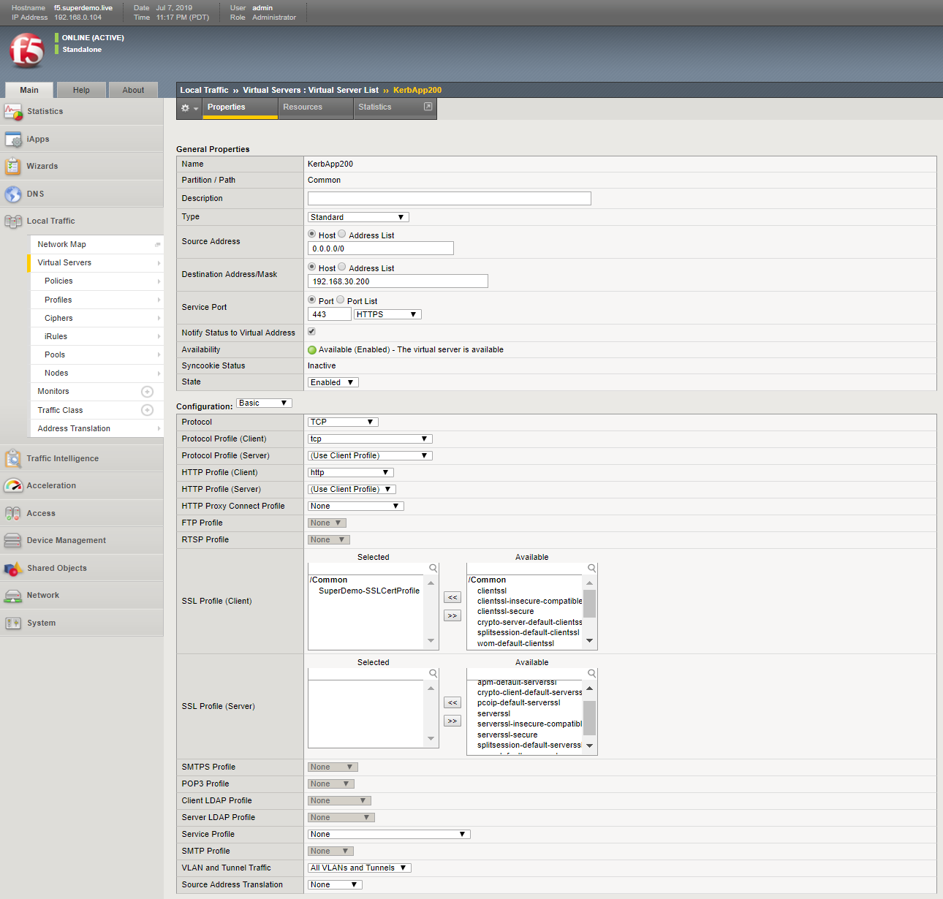

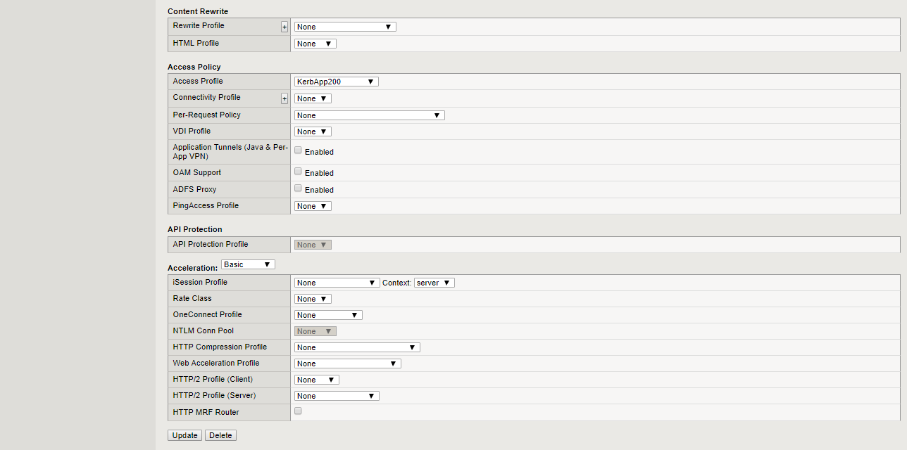

### **Setting up Kerberos Delegation**

Note: Reference <https://www.f5.com/pdf/deployment-guides/kerberos-constrained-delegation-dg.pdf>

**Step 1:** Create a Delegation Account

Example

Domain Name : **superdemo.live**

Sam Account Name **: big-ipuser**

New-ADUser -Name "APM Delegation Account" -UserPrincipalName host/big-ipuser.superdemo.live@superdemo.live -SamAccountName "big-ipuser" -PasswordNeverExpires $true -Enabled $true -AccountPassword (Read-Host -AsSecureString "Password!1234")

**Step 2:** Set SPN (on the APM Delegation Account)

example

setspn –A **host/big-ipuser.superdemo.live** big-ipuser

**Step 3:** SPN Delegation ( for the App Service Account)

Setup the appropriate Delegation for the F5 Delegation Account.

In the example below, APM Delegation account is being configured for KCD for FRP-App1.superdemo.live app.

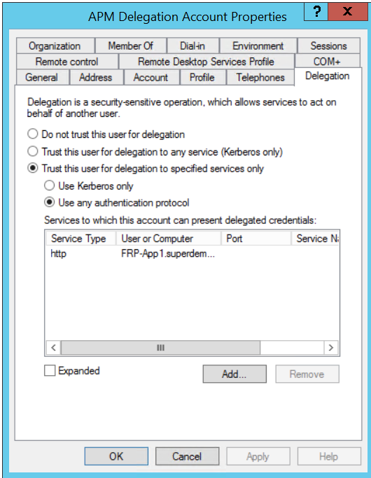

Provide the details as mentioned in the above reference document under

<https://techdocs.f5.com/kb/en-us/products/big-ip_apm/manuals/product/apm-authentication-single-sign-on-11-5-0/2.html>

# Appendix

## SAML – F5 BIG-IP Variable mappings

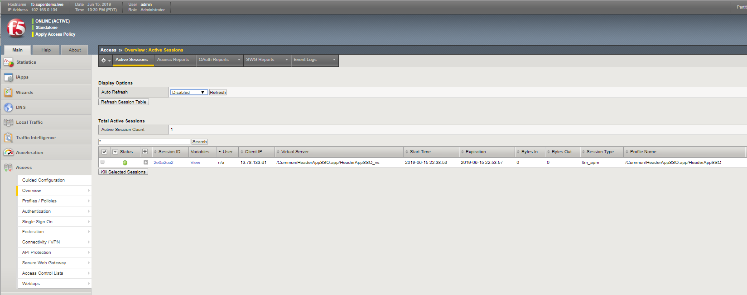

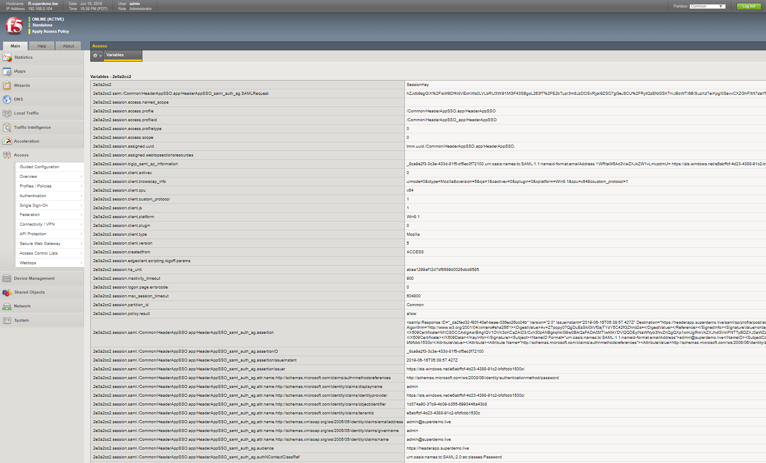

Below is the whole list of default SAML Attributes. GivenName is represented using the following string.

**session.saml.last.attr.name.http://schemas.xmlsoap.org/ws/2005/05/identity/claims/givenname**

|  |  |
| --- | --- |
| b46b6b6.session.saml.authnreq | <samlp:AuthnRequest xmlns:samlp="urn:oasis:names:tc:SAML:2.0:protocol" AssertionConsumerServiceURL="https://kerbapp.superdemo.live/saml/sp/profile/post/acs" Destination="https://login.microsoftonline.com/e6abffcf-4d23-4388-91c2-bfdfcbb1530c/saml2" ID="_b9c67faa63a224d7a63f4f3cbb09f78dc05fab" IssueInstant="2019-06-16T19:17:06.002Z" ForceAuthn="false" ProtocolBinding="urn:oasis:names:tc:SAML:2.0:bindings:HTTP-POST" Version="2.0"><saml:Issuer xmlns:saml="urn:oasis:names:tc:SAML:2.0:assertion">https://kerbapp.superdemo.live</saml:Issuer><samlp:NameIDPolicy AllowCreate="true"/></samlp:AuthnRequest> |
| eb46b6b6.session.saml.last.assertionID | _9a4e4ddd-148f-45c4-b959-f4d148172e00 |
| eb46b6b6.session.saml.last.assertionIssueInstant | 2019-06-16T19:18:03.054Z |
| eb46b6b6.session.saml.last.assertionIssuer | https://sts.windows.net/e6abffcf-4d23-4388-91c2-bfdfcbb1530c/ |
| eb46b6b6.session.saml.last.attr.name.http://schemas.microsoft.com/claims/authnmethodsreferences | http://schemas.microsoft.com/ws/2008/06/identity/authenticationmethod/password |
| eb46b6b6.session.saml.last.attr.name.http://schemas.microsoft.com/identity/claims/displayname | user0 |
| eb46b6b6.session.saml.last.attr.name.http://schemas.microsoft.com/identity/claims/identityprovider | https://sts.windows.net/e6abffcf-4d23-4388-91c2-bfdfcbb1530c/ |
| eb46b6b6.session.saml.last.attr.name.http://schemas.microsoft.com/identity/claims/objectidentifier | 90d5f0e5-8f46-4bfd-b40f-ec973d00fcb7 |
| eb46b6b6.session.saml.last.attr.name.http://schemas.microsoft.com/identity/claims/tenantid | e6abffcf-4d23-4388-91c2-bfdfcbb1530c |
| eb46b6b6.session.saml.last.attr.name.http://schemas.xmlsoap.org/ws/2005/05/identity/claims/emailaddress | user0@superdemo.live |
| eb46b6b6.session.saml.last.attr.name.http://schemas.xmlsoap.org/ws/2005/05/identity/claims/givenname | user0 |
| eb46b6b6.session.saml.last.attr.name.http://schemas.xmlsoap.org/ws/2005/05/identity/claims/name | user0@superdemo.live |
| eb46b6b6.session.saml.last.attr.name.http://schemas.xmlsoap.org/ws/2005/05/identity/claims/surname | 0 |
| eb46b6b6.session.saml.last.audience | https://kerbapp.superdemo.live |
| eb46b6b6.session.saml.last.authNContextClassRef | urn:oasis:names:tc:SAML:2.0:ac:classes:Password |
| eb46b6b6.session.saml.last.authNInstant | 2019-06-16T19:18:00.318Z |
| eb46b6b6.session.saml.last.identity | user0@superdemo.live |
| eb46b6b6.session.saml.last.inResponseTo | _b9c67faa63a224d7a63f4f3cbb09f78dc05fab |
| eb46b6b6.session.saml.last.nameIDValue | user0@superdemo.live |
| eb46b6b6.session.saml.last.nameIdFormat | urn:oasis:names:tc:SAML:1.1:nameid-format:emailAddress |
| eb46b6b6.session.saml.last.responseDestination | https://kerbapp.superdemo.live/saml/sp/profile/post/acs |
| eb46b6b6.session.saml.last.responseId | _a1eca95a-6c41-449e-bb53-1477ba106470 |
| eb46b6b6.session.saml.last.responseIssueInstant | 2019-06-16T19:18:03.070Z |
| eb46b6b6.session.saml.last.responseIssuer | https://sts.windows.net/e6abffcf-4d23-4388-91c2-bfdfcbb1530c/ |
| eb46b6b6.session.saml.last.result | 1 |
| eb46b6b6.session.saml.last.samlVersion | 2.0 |
| eb46b6b6.session.saml.last.sessionIndex | _9a4e4ddd-148f-45c4-b959-f4d148172e00 |
| eb46b6b6.session.saml.last.statusValue | urn:oasis:names:tc:SAML:2.0:status:Success |
| eb46b6b6.session.saml.last.subjectConfirmDataNotOnOrAfter | 2019-06-16T19:23:03.054Z |
| eb46b6b6.session.saml.last.subjectConfirmDataRecipient | https://kerbapp.superdemo.live/saml/sp/profile/post/acs |
| eb46b6b6.session.saml.last.subjectConfirmMethod | urn:oasis:names:tc:SAML:2.0:cm:bearer |
| eb46b6b6.session.saml.last.validityNotBefore | 2019-06-16T19:13:03.054Z |
| eb46b6b6.session.saml.last.validityNotOnOrAfter | 2019-06-16T20:13:03.054Z |

## Adding Custom Claims

As a part of your Azure Active Directory Application SAML SSO Setting, you can either modify the mappings or add additional attribute mappings.

